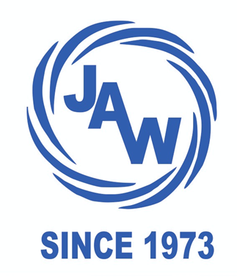

**JANATHA AUTO WORKS**



#10, JANATHA COMPLEX, NEAR BALA TALKIES, HAMPI ROAD, HOSPET-583201

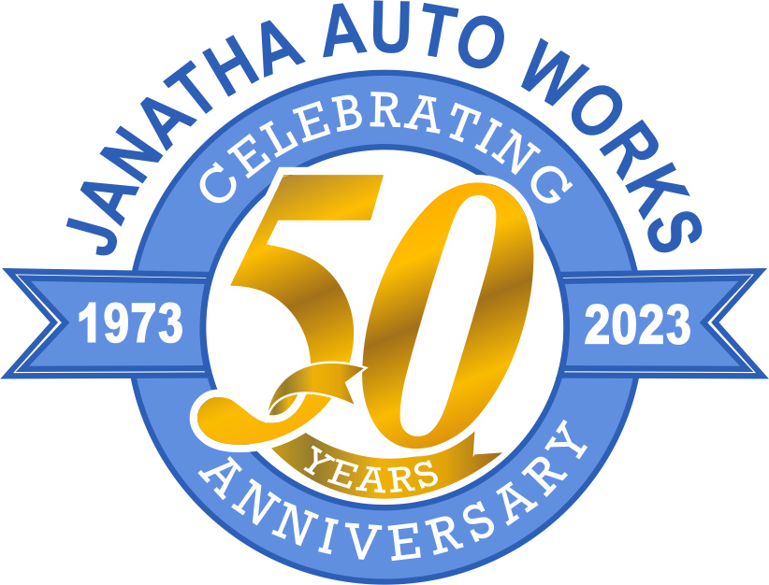

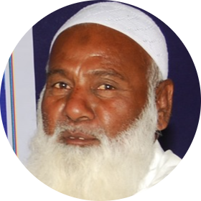

**Founder Day**

**JANATHA AUTO WORKS**

**50th Anniversary : 16.12.2024**

أعوذ بالله من الشيطان الرجيم

I seek refuge in Allah from the outcast Shaitan

بِسْمِ اللهِ الرَّحْمٰنِ الرَّحِيْم

Bismillahi ir Rehman nir Rahim

In The Name of Allah The Most Gracious, The Most Merciful ِ

الْحَمْدُ لِلَّهِ الَّذِي بِنِعْمَتِهِ تَتِمُّ الصَّالِحَاتُ

(Alhamdulillah alladhi bini’amatihi tatimmu as-salihat)

(Sunan Ibn Majah)

All praise is due to Allah

by whose favor good works are accomplished.

"Tamam tareef Allah ke liye hai jiske fazal se achhe kaam mukammal hote hain."

As Salaam Alaikum Wa Rehmatullahi wa Barkatahu

WELCOME TO

JANATHA AUTO WORKS



We wholeheartedly welcome you all to this special occasion of Janatha Auto Works' **50th anniversary**. This day is not just a celebration; it is a reflection of our **50-year journey, our dedication, and our hard work**. We are honored to share this memorable day with you, and your presence here is a source of pride and happiness for us.



JANATHA AUTO WORKS  
Since 1973



"This presentation will take you through the **remarkable journey** of **Janatha Auto Works**—a journey filled with **hard work, determination, and success**.  
It is also a tribute to those whose **commitment and dedication** made this journey possible."

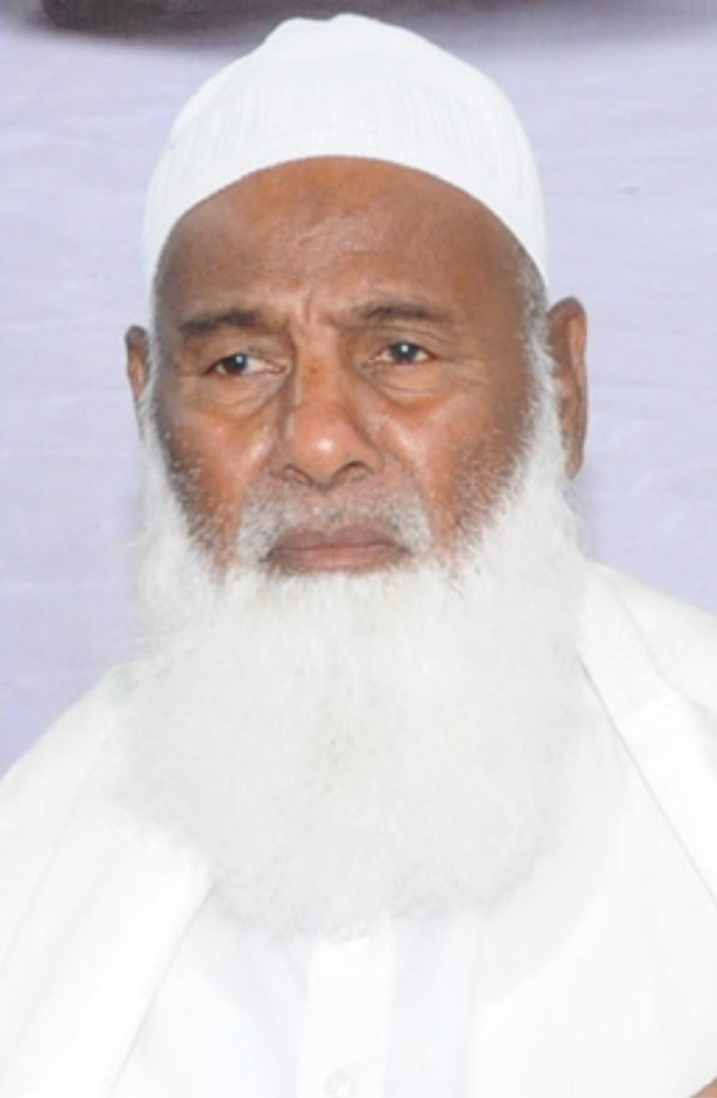**Founder: Late Gooty Dada Sab,**

"Our story begins in 1949, when the construction of the Tungabhadra Dam started. This project created new job opportunities in the area, and many people from surrounding regions migrated to Hospet and its nearby areas to settle down.

Our family’s journey also began around this time when our family moved from Gooty (which is now in Andhra Pradesh) to Hospet. Our grandfather, Mr. Nadeem Sab, was the first member of the family to come here, and he found work as a driver. Despite life's challenges and struggles, with wisdom and hard work, our family, by Allah's grace, managed to make a living here and settled successfully in Hospet.

In 1957, our grandfather’s older brother, Mr. Mohammad Sab, along with his brothers, started the first automobile repair workshop in Hospet, ‘General Auto Works.’ It was a small but hopeful beginning. After working for almost 15 years with his older brother, G. Dada Sab chose to take a different path and, along with two of his friends, embarked on a new journey.

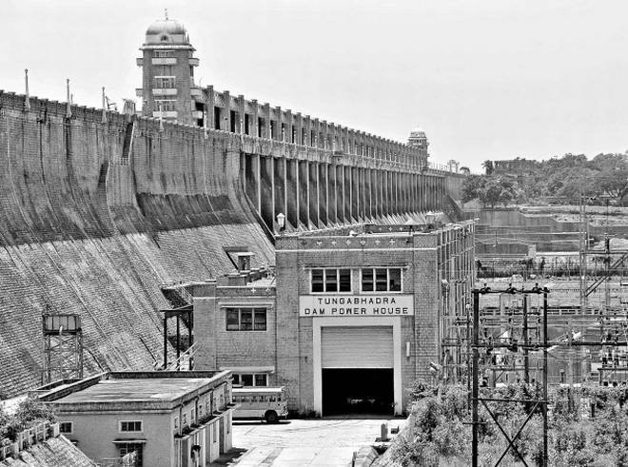In 1973, upon the advice of a close associate, G. Dada Sab, along with his friends, started a small garage in Gangavathi and named it ‘Janatha Auto Works.’ At that time, there were no automobile repair shops around Gangavathi, so people were forced to travel to Hospet or Bellary for even the smallest repairs. This decision turned out to be perfectly timed.

In the beginning, work wasn’t much, but it was enough to support the families of the three friends. With the help of friends and family, like my late brother Marhoom Jaleel Sab and Marhoom Sadiq Sab, the work gradually progressed. Over time, other family members and people joined, and the workshop continued to prosper.

In 1982, our older brother, Mr. Marhoom Nooruddin, began assisting our father, G. Dada Sab, in the work. Later, our uncle, Mr. Khairulla T, and other friends and acquaintances also joined in.

At the garage, we used to service the famous brands of vehicles from those days, such as: DODGE, BEDFORD, TATA, ASHOK LEYLAND, MITSUBISHI, FARGO, WILLYS, BENZ, DAEWOO, and ROCKET. We serviced buses, trucks, jeeps, matadors, as well as road rollers and harvesters. This was not just a business; it was the fulfillment of a dream and an example of the spirit of a family and friends that still lives on."

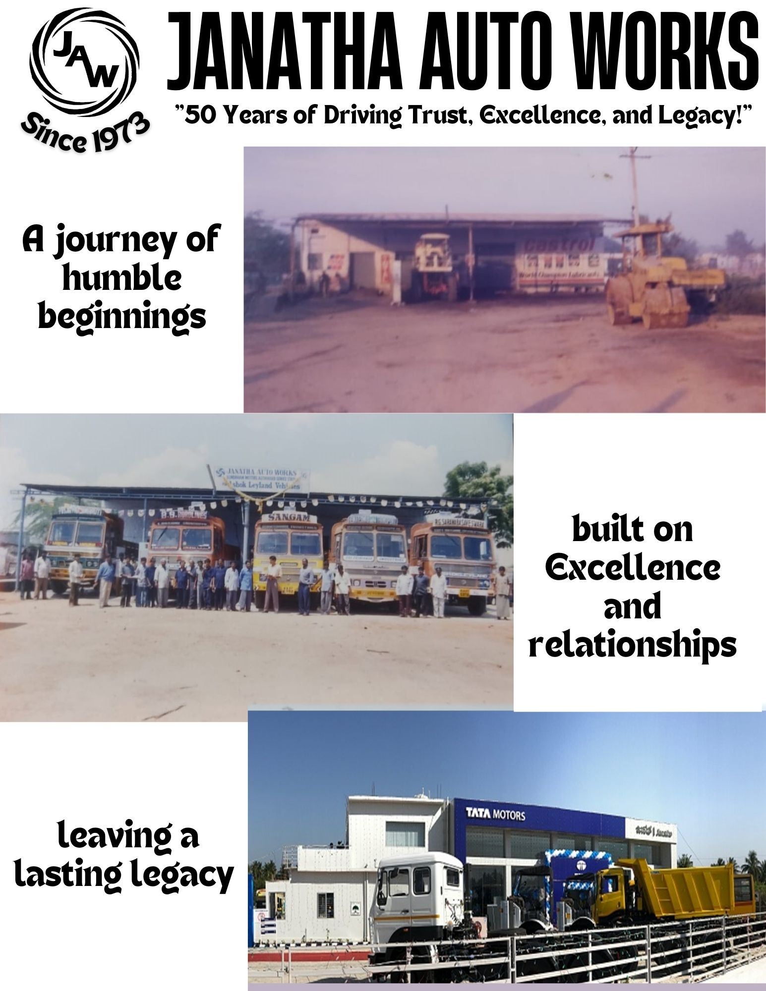

After staying together for almost 10 years, the three friends decided to expand the business. In 1982, one started a workshop in Hospet, and the other friend opened one in Chitradurga.



"As the business gained momentum, in 1983, the need was felt to meet the demand for spares and service in Kushtagi market. Under the leadership of my younger brother, Mr. G. Jaleel Saheb, a 2S shop was established in 1983. This was the first expansion of Janatha Auto Works outside of Gangavathi."

After working tirelessly for ten years in a small garage on rented land, Janatha Auto Works had established a strong reputation in Gangavathi and the surrounding areas.

As the business expanded, the need for a larger and more suitable location became increasingly evident. Overcoming various challenges, we successfully purchased an acre of land in Gangavathi in 1983.

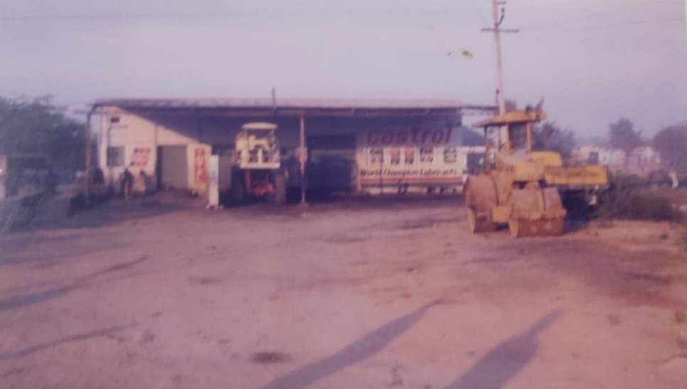Following another decade of hard work, we built our new workshop on this land in 1992, which featured six bays."

"This workshop proved to be instrumental in managing our growing work and business more efficiently.

It became the central hub for servicing all types of small and large vehicles in Gangavathi and the surrounding areas. As mentioned earlier, it became well-known for servicing vehicles of every brand and had earned the trust of people for its quality of work.

In 1993, Aslam Pasha joined the business, and in 1995, Nasir Hussain also became a part of it. Both contributed by sharing the responsibilities of managing the work and helping to take the business to the next level, working alongside their father and elder brother."

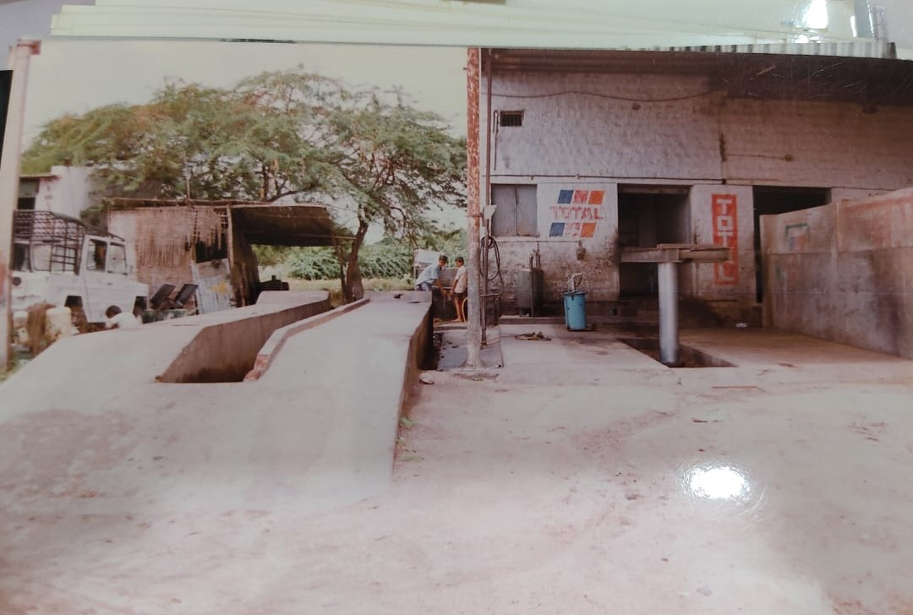"With the intention of improving our work and providing more value to our customers, a water service shop was started in 1996."

"The very next year, in 1997, under the leadership of Aslam Bhai and his mentor Noor Khan Sab, a machine shop was also established. This machine shop proved to be highly beneficial in increasing the speed of work and improving efficiency."

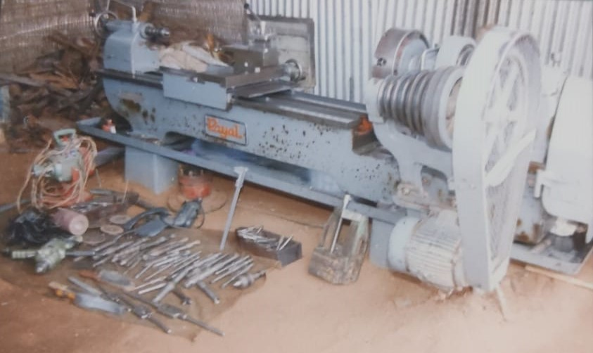

"Work that previously had to be outsourced was now being done in-house, which not only saved time but also improved the quality of work and increased customer satisfaction."

🡪After nearly 27 years since its inception, in 2001, an opportunity arose to collaborate with Sundaram Motors, which at that time was the dealer for Ashok Leyland in the region.

They approached Janatha Auto Works to offer our services as an authorized service center for Ashok Leyland vehicles.

Since we had been servicing various brands of vehicles from the beginning, we initially didn’t feel comfortable limiting ourselves only to Leyland vehicles. However, after discussions with the responsible parties and thorough consultation within the family, it was decided that this opportunity should not be missed, and an attempt should be made.

Thus, in 2001, Janatha Auto Works became the Sundaram Motors Authorized Service Station (SMASS) and began offering services for Ashok Leyland vehicles in Gangavathi.

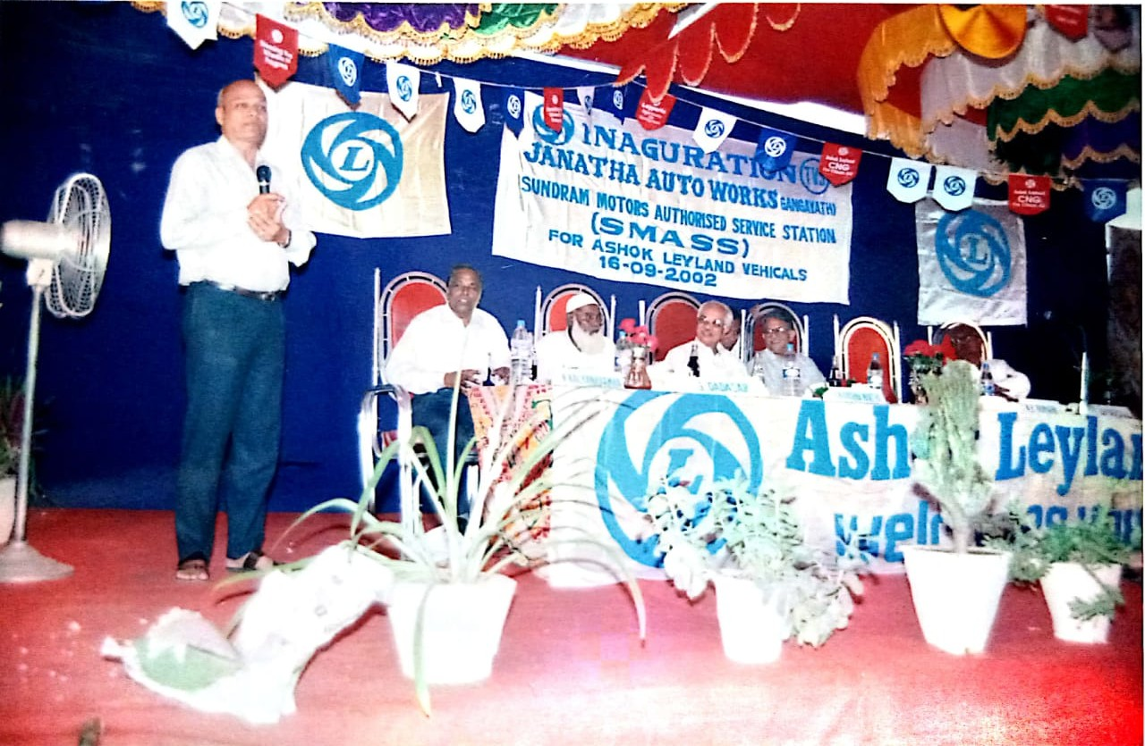

"In 2001, our workshop was given a renovated look as a Sundaram Motors Authorized Service Station (SMASS).

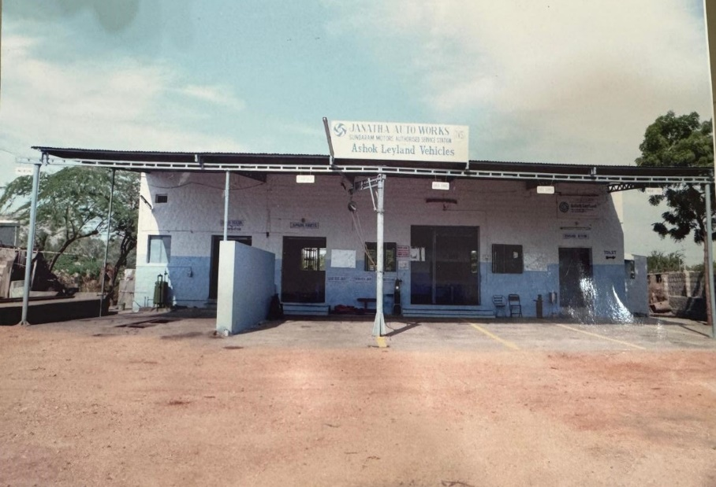Despite this dedicated workshop for Ashok Leyland vehicles, we also set up a separate multi-brand workshop through which we were able to continue servicing our old and loyal customers."

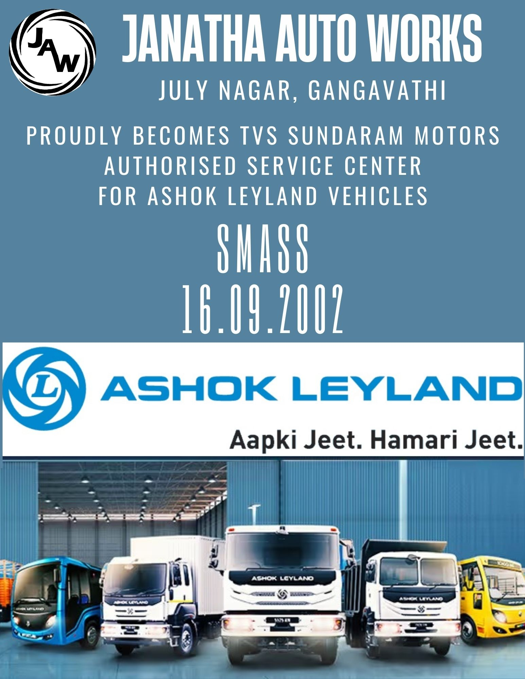

* 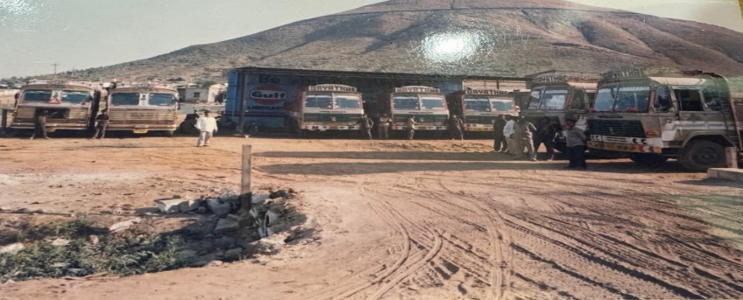"As an authorized service center, the business was running well in Gangavathi. Then, Sundaram Motors suggested opening a service workshop in Hospet. A few years later, mining activities in the region began to intensify in 2002.

The need was felt to establish a presence in Hospet as well. To meet this, land was rented near the RTO office in Hospet, and in 2003, we launched our second workshop.

Under the supervision of my older brother, Mr. Nooruddin, this workshop began operations, and his younger brother, Shafiulla, also joined him."

"In 2004, a new machine shop was established at the Hospet workshop.

All the machining work that was previously outsourced or brought in from our Gangavathi workshop, was now done at the Hospet workshop itself. This greatly improved the efficiency of the workshop’s services, and we became successful in delivering vehicles to customers as quickly as possible.

This machine shop was also started under the leadership of Aslam Bhai and Noor Khan Sab."

* "While working as an authorized center for Ashok Leyland, we often faced the problem of having to send power steering systems for repairs to Hubli, Belgaum, or Bangalore, and we had to rely on authorized vendors for these services. The repair of power steering systems would take a long time.

To solve this problem, we approached RANE Power Steering Systems to become their Authorized Service Center. 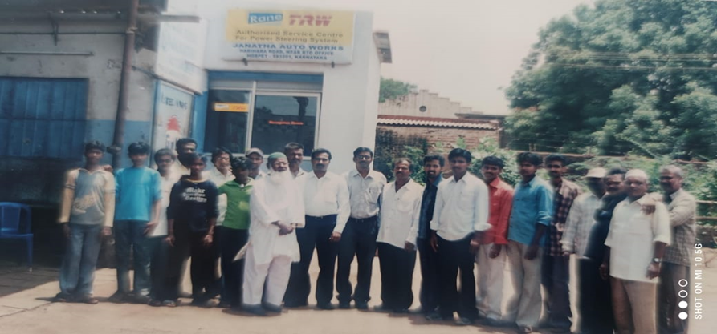After nearly two years of follow-up, by Allah's grace, in 2007, we were given the opportunity to become an Authorized Service Center for RANE TRW Power Steering Systems. This facility was set up within the premises of our Hospet workshop, and the responsibility for this new division was entrusted to my younger brother, Mr. Saifulla."

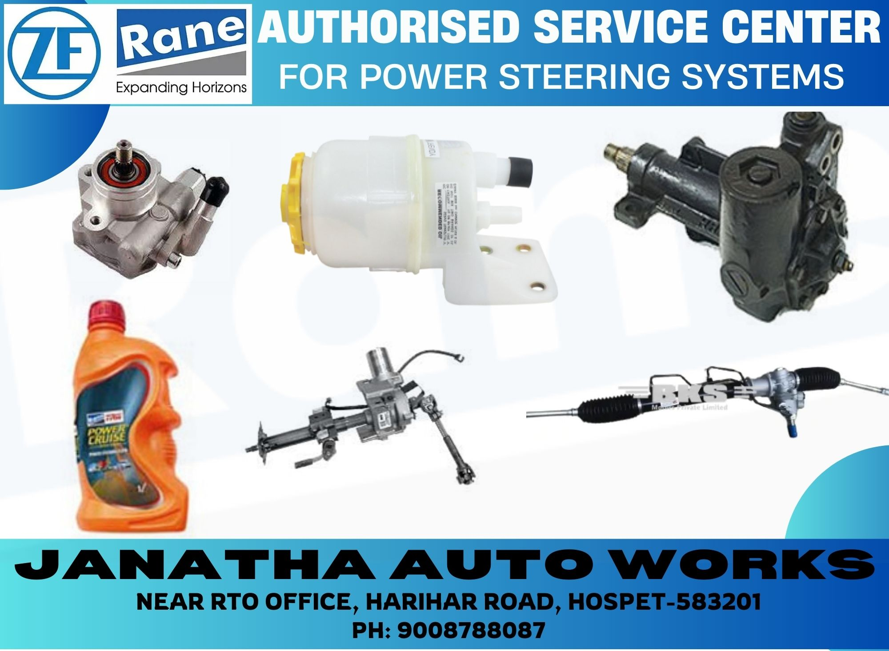

**Slide 16 -**

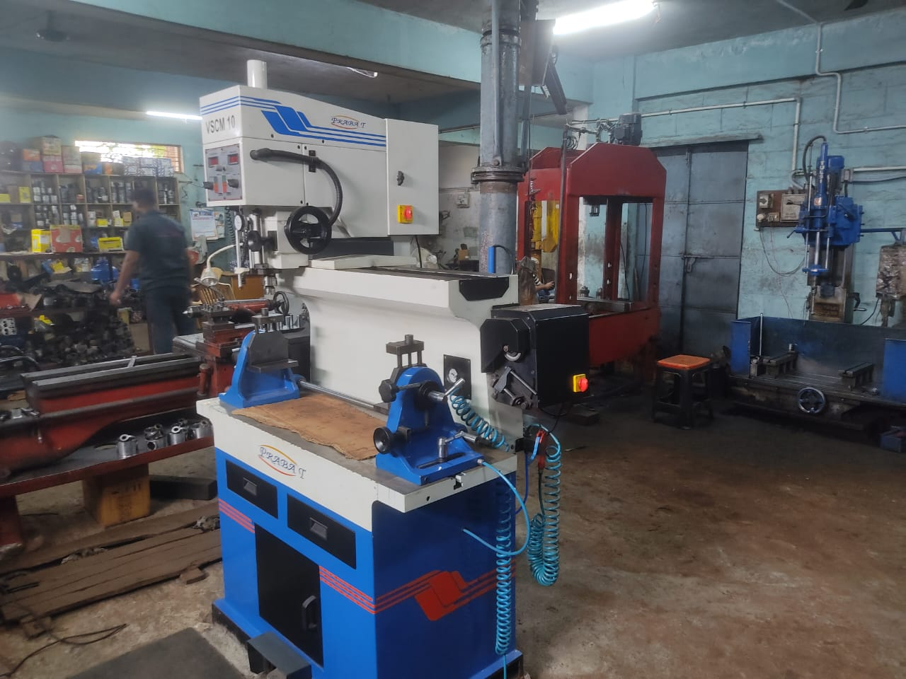"During the mining boom, the Hospet workshop was filled with vehicles every day. At its peak, nearly 35 vehicles would be serviced and sent out each day. Once those 35 vehicles were done, another 50 vehicles would be waiting outside the gate.

Today, we express our gratitude to all the people who worked alongside us during that time, shoulder to shoulder. Some of them are still with us, while others have moved on in life.

During this time, due to not having our own engine refurbishing services, many tasks were outsourced to vendors from Bangalore or other locations. This was affecting our delivery time and impacting customer satisfaction.

To address this issue, in 2008, we set up our own Engine Reboring Workshop in Hospet, which not only solved our own problem but also took a step towards fulfilling the growing demand for this specialized work in the region.

This facility was established on Hampi Road in Hospet, and the responsibility for this new division was entrusted to my younger brother, Mr. Shafulla."

**Slide 17 –**

"These are some pictures of our Hospet Reboring facility."

**Slide 18 –**

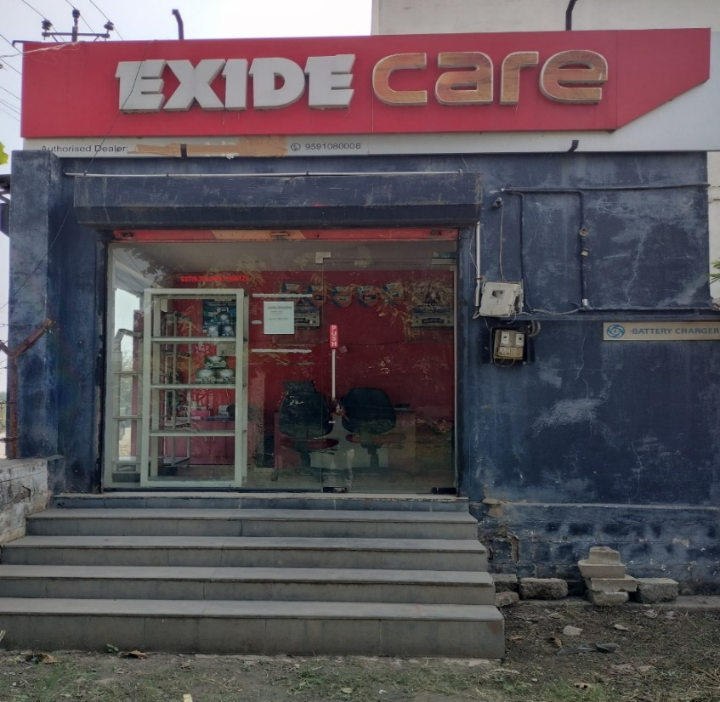"In the same business, we, the five brothers, became well-experienced in automobile service while working with our father. It started to feel like we should explore other opportunities as well. Since we had always faced problems with the warranty of vehicle batteries, we applied to Exide Batteries as a solution and with the intention of further expanding the business. They accepted our application, and in 2009, we were appointed as their distributor for the entire Koppal district (for Sales & Service)."

**Slide 19 -**

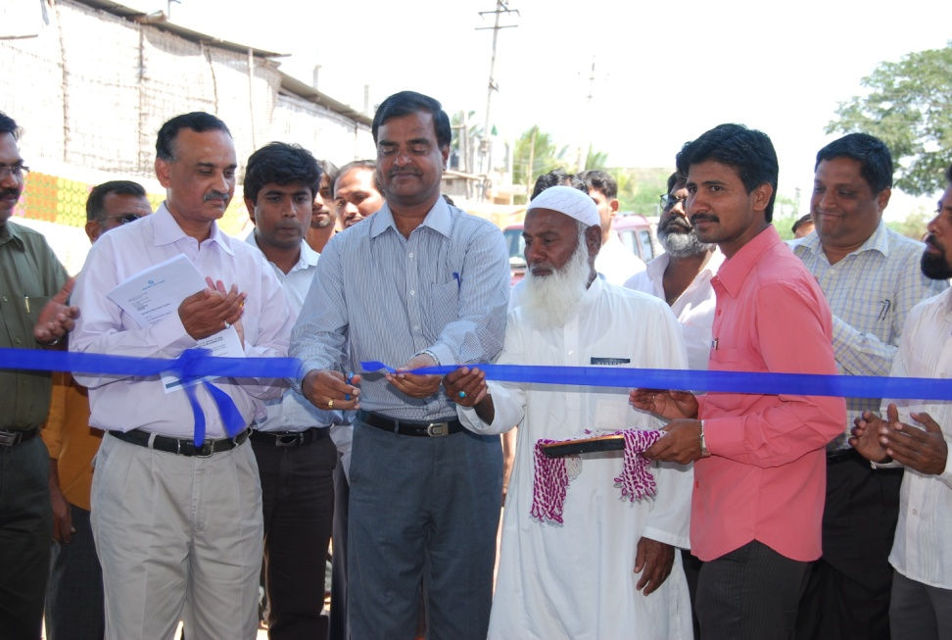"In 2010, Ashok Leyland introduced new rules, under which no dealer could appoint sub-dealers under their own name. As a result, Janatha Auto Works, which had been Sundaram Motors' Authorized Service Center, was directly appointed by Ashok Leyland as the Authorized Service Center for the entire Koppal district.

During this time, our Hospet workshop also became Ashok Leyland's Authorized Service Center for Bellary District.

This was the first time we established a direct relationship with an OEM, which greatly enhanced Janatha Auto Works' recognition and credibility."

**Slide 20 -**

"Ashok Leyland had sold 80 vehicles to JSW, and this deal was made with an at-site AMC (Annual Maintenance Contract). To provide service for these vehicles, Ashok Leyland appointed Janatha Auto Works as the Authorized Service Provider.

This was an 'at-site AMC' agreement, under which comprehensive bumper-to-bumper service was to be provided. The agreement, for 80 vehicles, was running at the mines in Sandur. This contract was for 5 years, with 24X7, 3-shift availability."

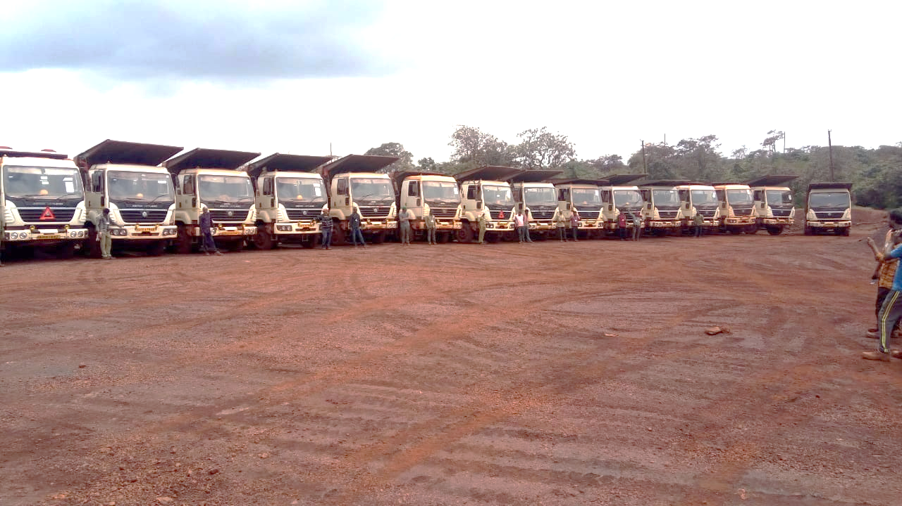

"This AMC contract proved to be a significant milestone in the journey of Janatha Auto Works. We secured this AMC contract in 2011, which lasted until 2015. The target was to keep 85% of the vehicles always on the road, but over the course of those 5 years, we consistently kept 95% or more of the vehicles on the road, establishing a service record of consistent performance."

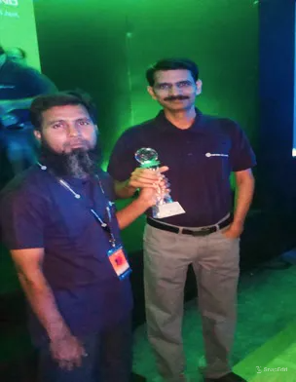**Slide 21 -**

"For our excellent service, we were also honored with an Appreciation Award from Ashok Leyland, which was a great honor and a source of encouragement for us.

This award was presented during the Dealer Conference in 2015 and was given for being the No. 1 Ashok Leyland ASC (Authorized Service Center) in PAN India."

**Slide 22 –**

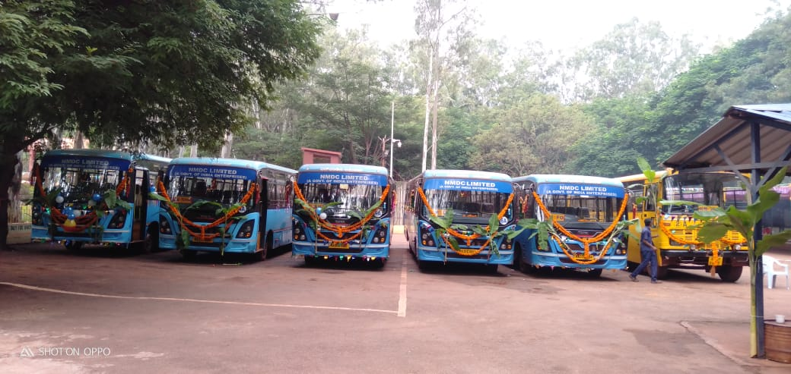"To further expand the business, we started trying to offer our services to mining companies as well. In 2011, while we were executing the AMC for JSW, this helped us significantly in securing a work order from NMDC.

This AMC contract from NMDC was for the maintenance of their 8 Ashok Leyland staff buses.

Initially, for 7 years, we provided service for their Ashok Leyland buses, and then in 2018, when we became TATA Motors Dealers, we transitioned this AMC contract for TATA buses.

This 'at-site AMC contract' has been ongoing since 2011 and continues to this day."

**Slide 23 –**

"Due to the increased flow of vehicles in Torangallu, following JSW’s presence, Ashok Leyland suggested that we should also start an Authorized Service Workshop in Kurekuppa.

Recognizing the importance of this suggestion, we first purchased 1.5 acres of land here and set up a container workshop.

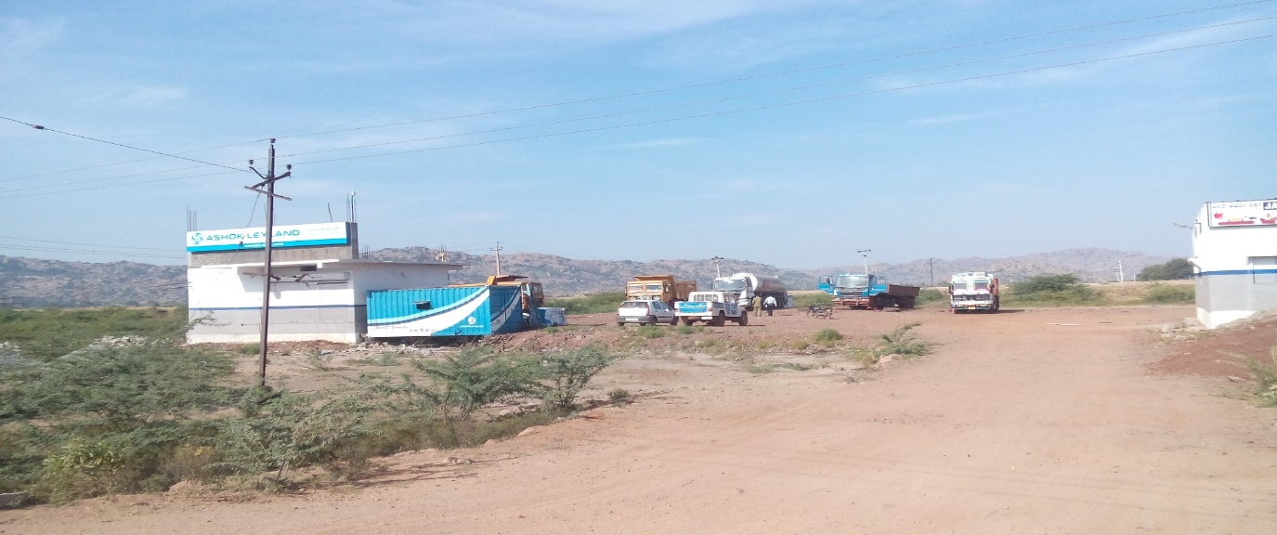Later, in 2012, this was upgraded into a 7-bay workshop, and during our time as TATA Motors dealers in 2018, it was further upgraded into a fully operational 15-bay workshop."

**Slide 24 –**

"During our time as an authorized service center for Ashok Leyland, we often faced the issue that the turbo system had to be sent elsewhere for repairs, and we had to rely on authorized vendors for these services.

To address this issue, we directly applied to **Turbo Energy Limited**, aiming to establish an Authorized Service Center for their product in Hospet.

Considering our experience, facilities, and market reputation, our application was approved, and **in 2012, Janatha Auto Works was appointed as the Authorized Service Center (ASC) for Turbo Energy Ltd in the Bellary district**. This department began operations under the leadership of Janab Saifulla, and the TEL ASC continues to operate successfully."

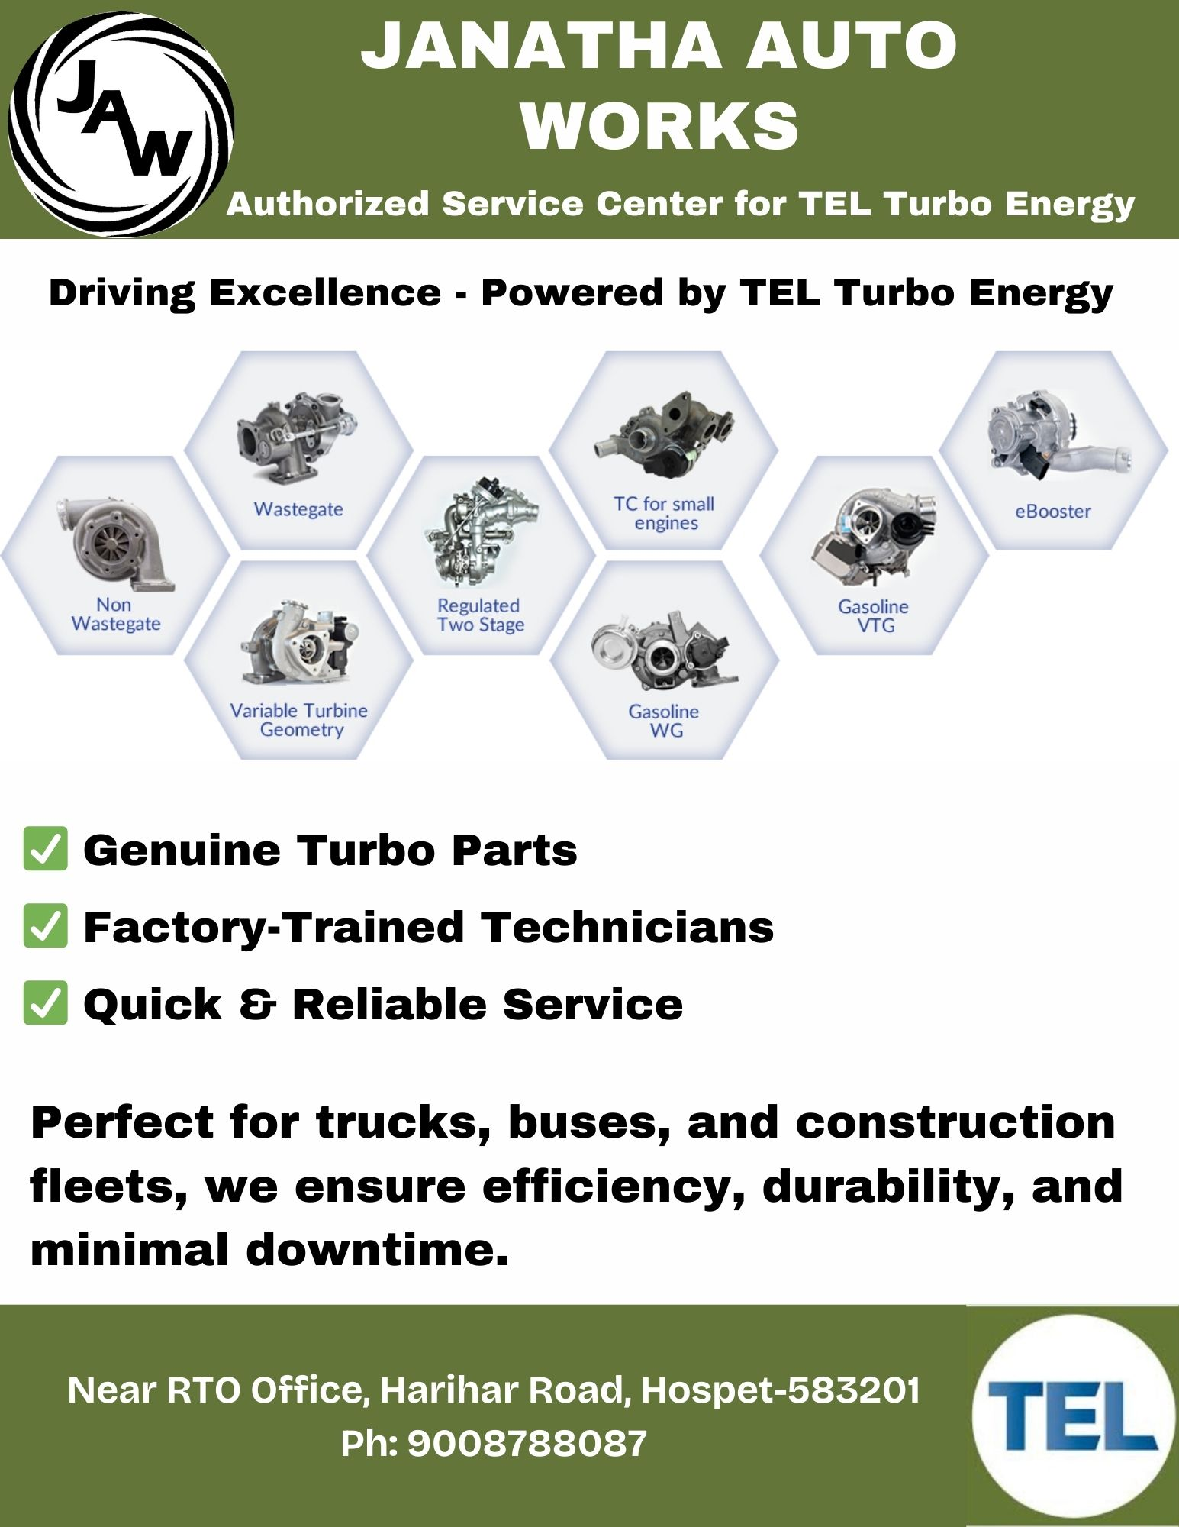

**Slide 25 -**

"Tel Turbo advised Janatha Auto Works that we should also have a presence as an Authorized Service Center (ASC) in the Chitradurga territory. Since there was no ASC in this territory and it was vacant, we decided to establish our presence in Chitradurga following this advice."

**Chitradurga**

 "We spoke to Rane Power Systems and WABCO Brake Systems and requested them to extend the ASC status to Janatha Auto Works in Chitradurga."

**Chitradurga**

 "Fortunately, approval from all three OEMs (Original Equipment Manufacturers) came through almost at the same time, and we started ASC operations for these three brands together in 2015."

**Chitradurga**

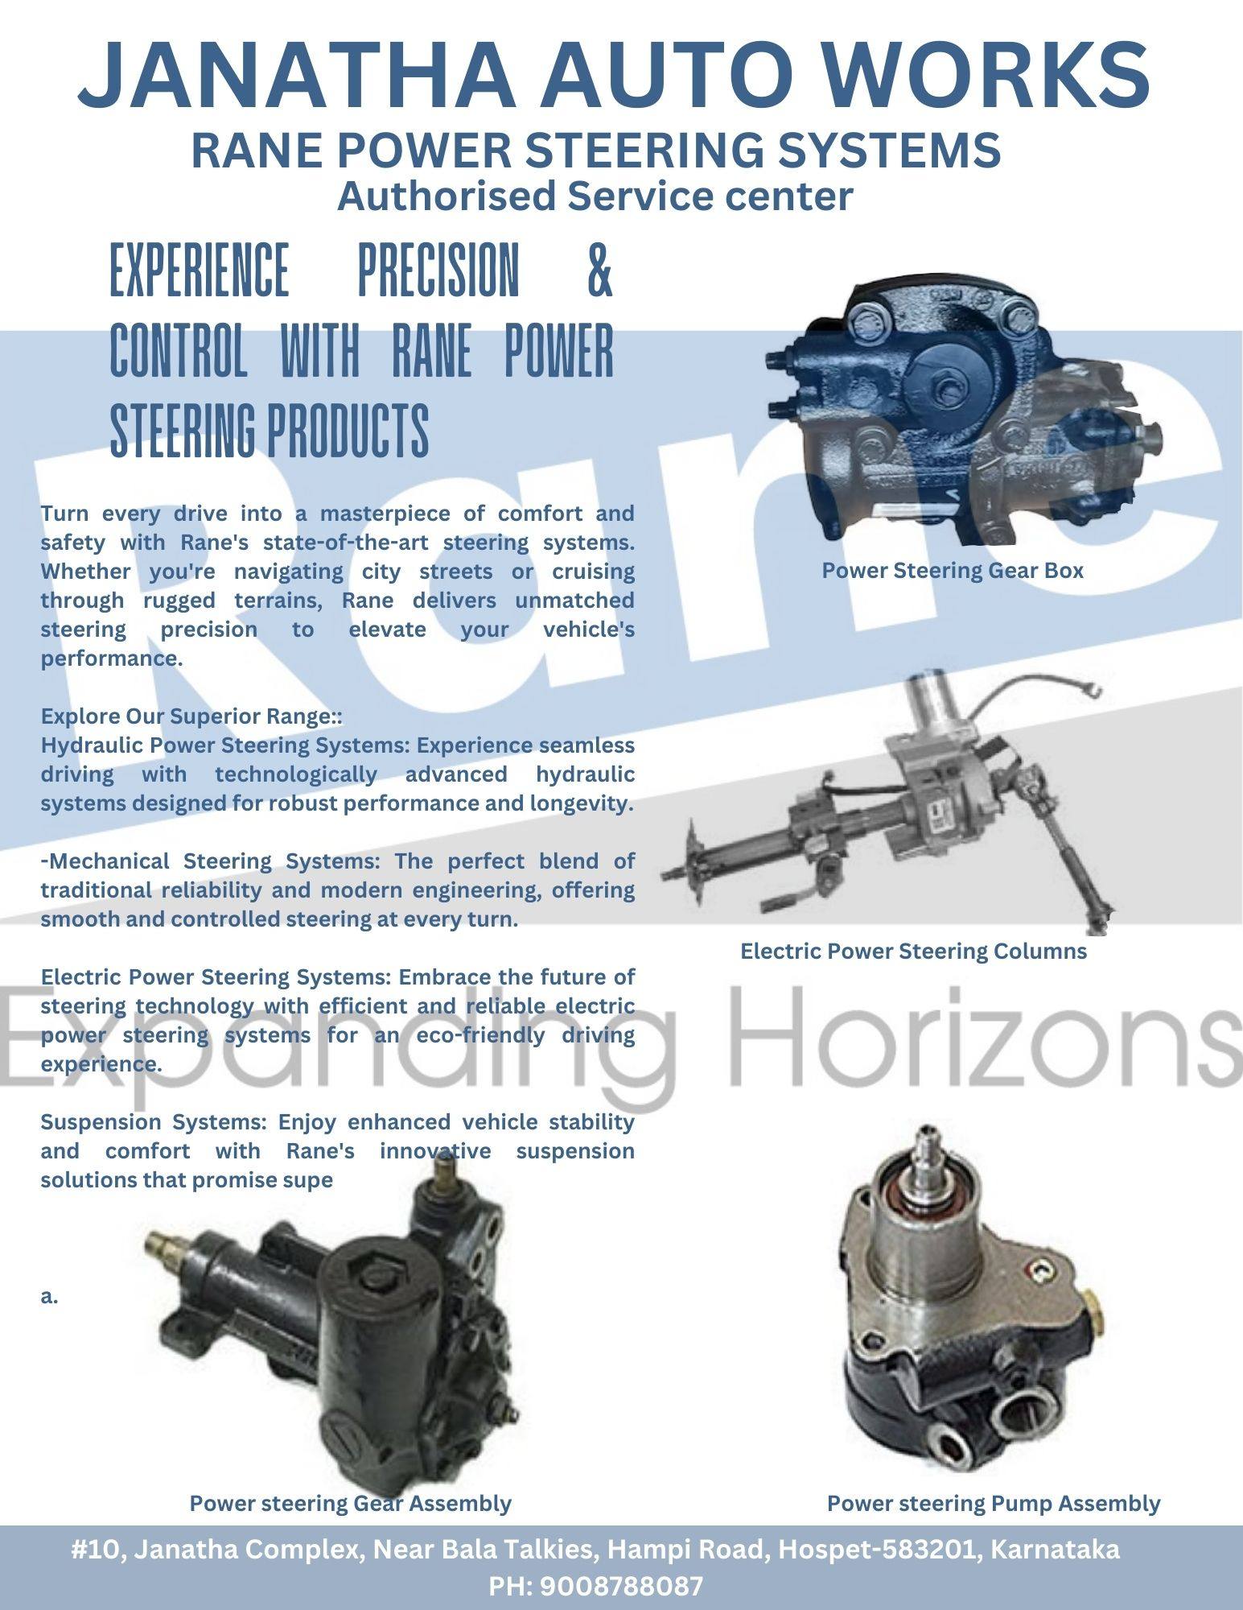

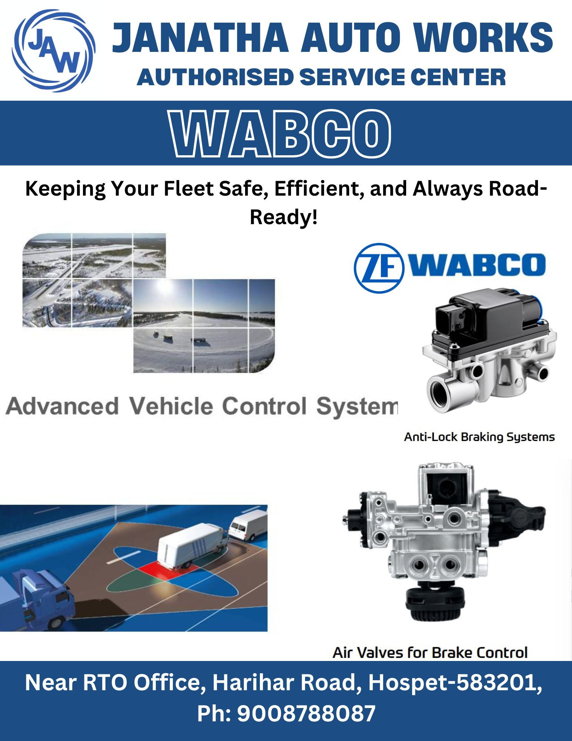

**Slide 26 -**

"These are the inauguration pictures of Janatha Auto Works becoming the Authorized Service Center for WABCO, TEL, and Rane TRW in Chitradurga in 2015."

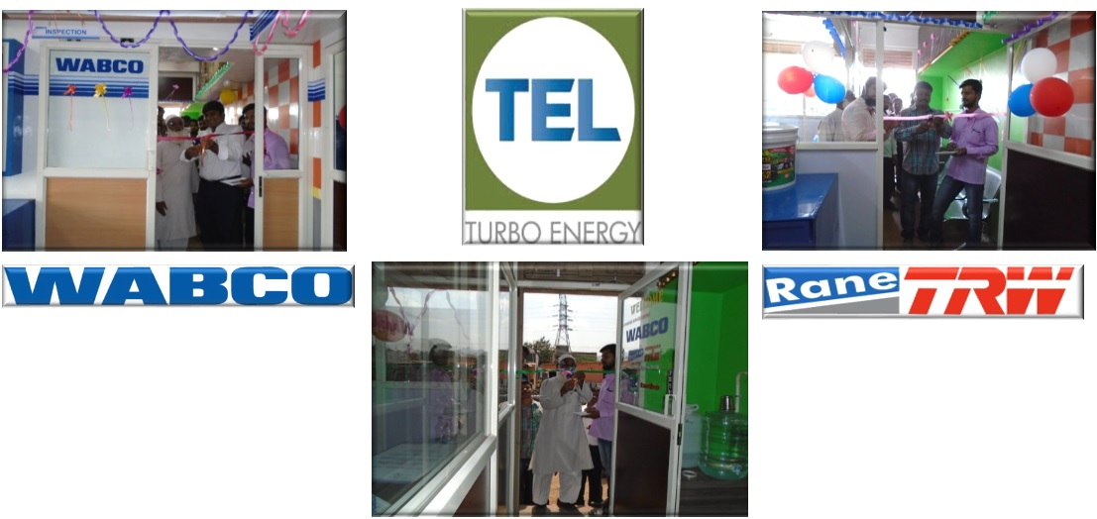

**Slide 27 -**

"On the advice of Ashok Leyland, container workshops were started in Belgaum and Bijapur in 2015, which operated as Authorized Service Centers for Ashok Leyland. These workshops continued to provide services from 2015 until 2018, even after joining TATA."

**Slide 28 -**

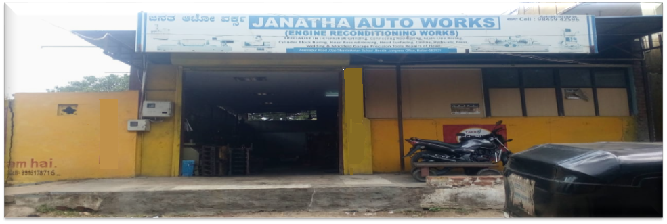"In 2016, we established our second Reboring workshop in Bellary. This decision was made due to the increasing demand for engine reboring services. Additionally, we wanted to stay closer to our customers to provide better services. This new workshop has helped us expand our reach in the Bellary region."

**Slide 29 -**

"These are a few pictures of our Bellary Reboring Workshop facility."

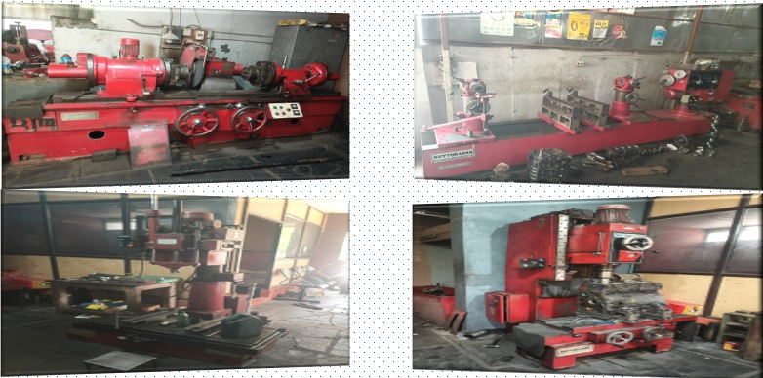

**Slide 30 –**

"With the intention of exploring other business options, we got connected with Rocktech Mining Contractor, who had a large work order for development work at the NMDC mines."



"In 2016, Rocktech made us their subcontractor for this work. To execute this work order, we deployed a fleet of 18 Ashok Leyland vehicles, which is still operational today."

**Slide 31 –**

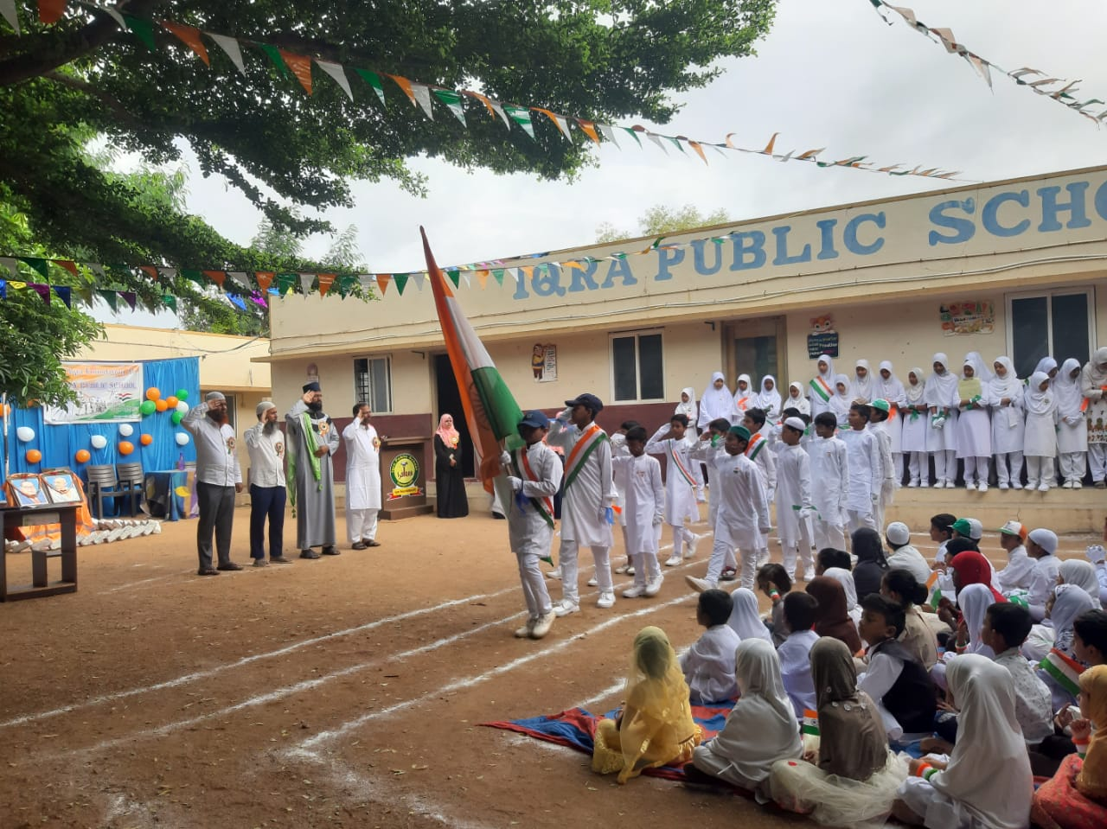"IQRA Public School Gangavathi was started with the intention of doing something for the betterment and progress of society. It was understood that most working-class people are not highly educated and belong to low-income groups. Therefore, an effort was made to establish a school that would provide quality education to their children at affordable rates and with minimal charges.

In 2016, IQRA Public School was established through the IQRA Foundation Trust. Permission was obtained from government authorities for classes from nursery to the 6th grade.

Initially, the community's response was mixed. Many people doubted our abilities and competence. However, through consistent efforts and engaging with people, we were able to explain our vision and succeeded in convincing some. Those who were convinced enrolled their children in the school.

Gradually, the demand for admissions started to grow. In the very first year, using all our resources, we successfully admitted 220 students for nursery and first grade. This was a great encouragement and relief for us.

Now, by the grace of Allah, after 9 years, we have received permission to offer classes up to the 10th grade. Today, nearly 500 children are receiving education at our school, with 30 teachers and 6 non-teaching staff members."

**Slide 32 – Nil, Slide 33 – Nil**

**Slide 34 –**

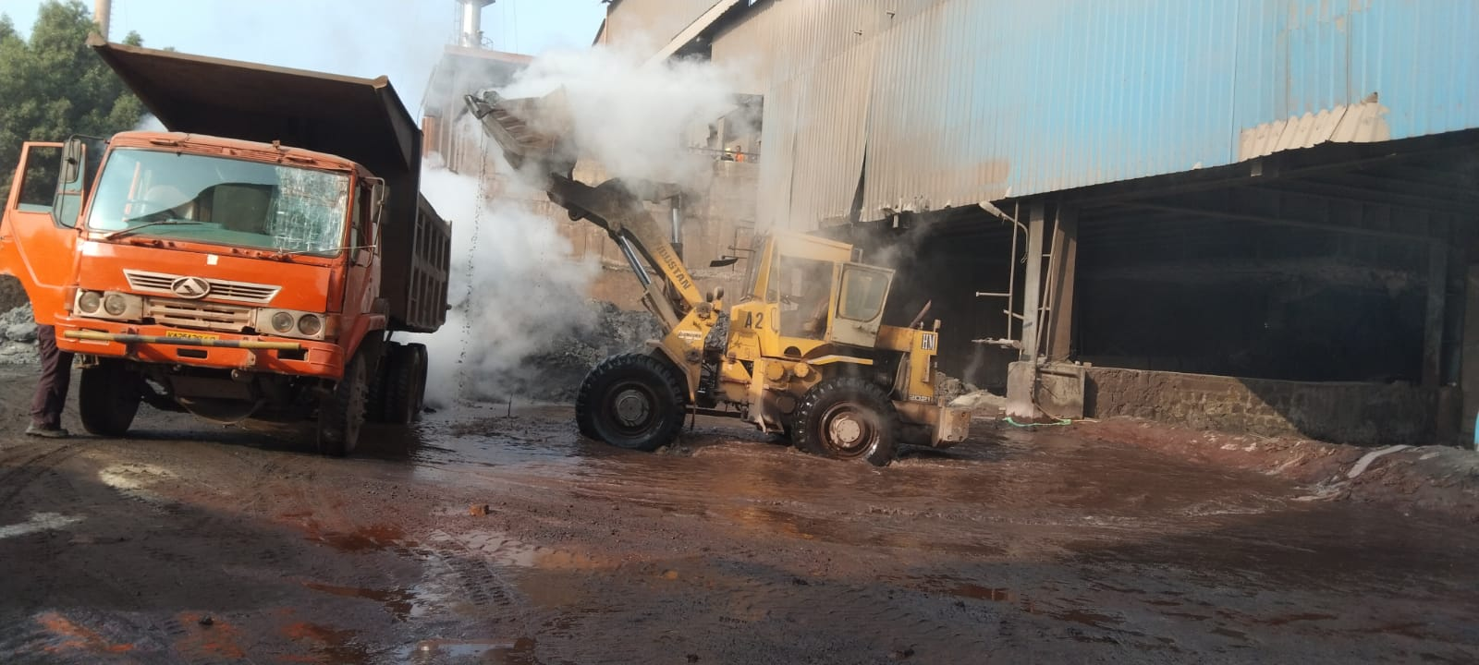"In 2017, we took on a significant challenge when we accepted the work order from SLR Metalliks. This was a 3-year project involving the shifting of hot metal slabs, which was beyond our traditional scope of work.

To carry out this task, we deployed 6 lorries, heavy machinery, and 2 excavators.

Through our hard work and dedication, we not only met expectations but also exceeded them significantly.

This venture proved to be an important milestone for us, demonstrating that our company has the full capability to accept new challenges and achieve success in them."

**Slide 35 –**

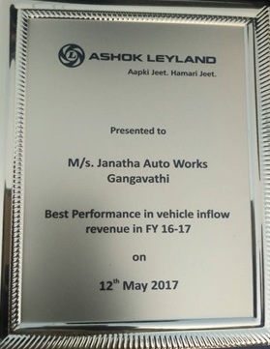"Our Gangavathi branch primarily catered to seasonal business,  
but we successfully expanded beyond our traditional market and generated consistent revenue growth.

Recognizing our outstanding performance,  
Ashok Leyland awarded us the Best Performance Award in 2016-17  
for achieving the highest vehicle inflow revenue (GVT) in the financial year."

**Slide 36 –**

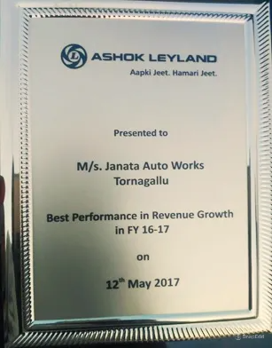"Our Kurekuppa branch achieved exceptional financial success.

For the 2016-17 financial year, Ashok Leyland awarded Kurekuppa ASC the Best Performance Award for achieving ₹8 crore in revenue. At that time, the workshop handled 15-20 vehicles daily, which reflected our dedicated service quality."

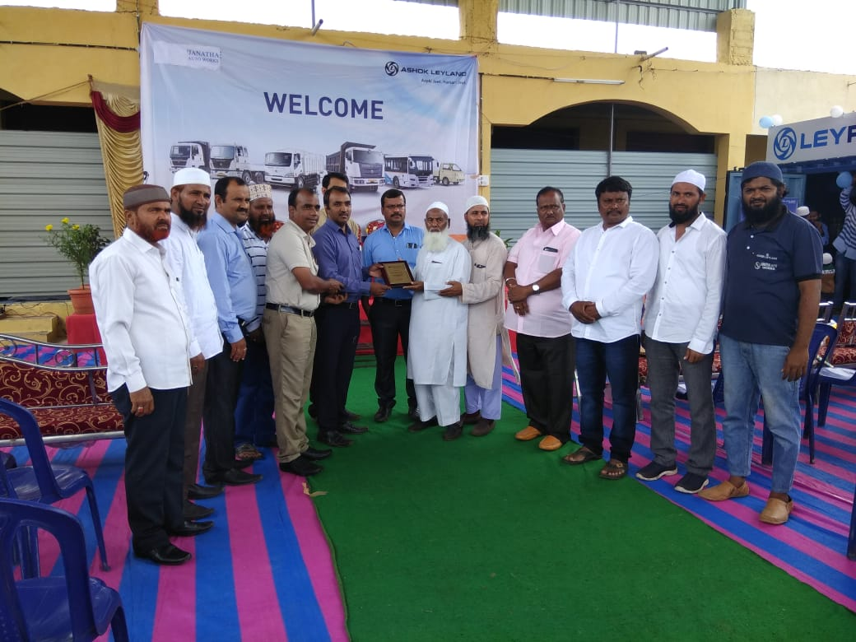**Slide 37 -**

"There was an opportunity to set up an Ashok Leyland Authorized Service Center (ASC) in Kudligi. We requested Ashok Leyland's Network Department to extend the authorization for the Kudligi territory as well.

This became our sixth Ashok Leyland Authorized Service Center (ASC), which was inaugurated in March 2018."

**Slide 38 -**

**"A New Journey in 2018: Janatha Automobiles Pvt Ltd was established as a Tata Motors Commercial Vehicles Dealer."**

Janatha Auto Works was famous in North Karnataka for its excellent service and trust. People praised our work and had full faith in our name. However, the thought of expanding the business was always in our mind. With this intention, since 2015, we had been trying to start the vehicle sales business.

The journey began by approaching Ashok Leyland, but for some reason, this partnership did not succeed. Later, we received offers from tractor and two-wheeler companies, which we seriously considered. During this time, we learned through a newspaper that Tata Motors was looking for a dealer for its commercial vehicles in North Karnataka.

This was a great opportunity. We immediately applied and started discussions with Tata Motors officials. The process was lengthy—there were several meetings, discussions, and facility inspections. Tata Motors analyzed our work and tried to understand our organization from every angle.

One important question they asked was: "Janatha Auto Works, which is well-known for service, how will it establish itself in the tough and competitive field of sales?"

In answering this, we demonstrated our years of experience, a strong database of loyal clients, and our ability to understand customer needs. We assured them that with a strong service foundation, we could also establish a successful sales operation. Our approach and determination convinced Tata Motors.

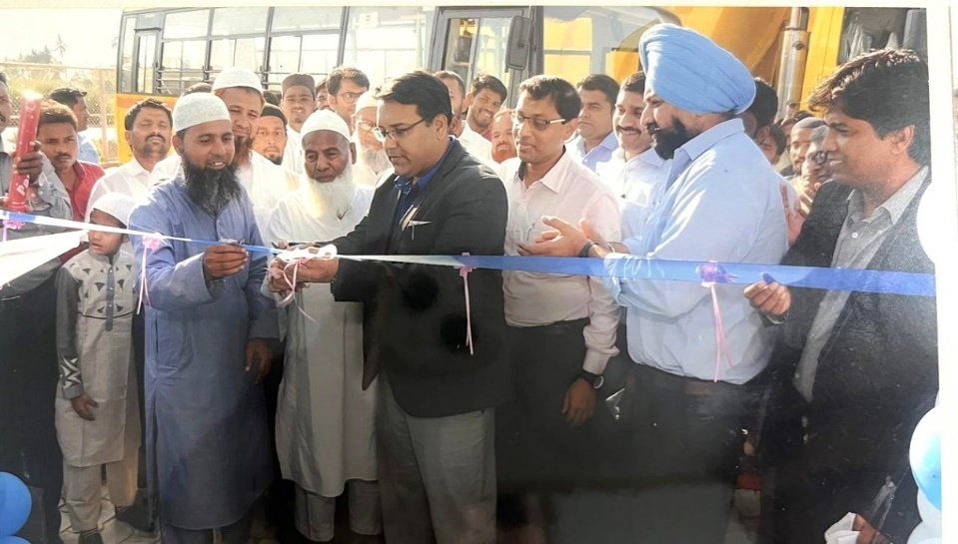Finally, in December 2018, we were formally appointed as a Tata Motors 3S dealership (Sales, Service, Spare Parts). This was not just a dealership; it marked the beginning of a new journey for Janatha Auto Works. It was a significant turning point that led us into a new sector of the automobile industry and gave us the opportunity to take our business to new heights.

This decision was not just about business expansion; it was a testament to the hard work, determination, and commitment of our team.

**Slide 39 -**

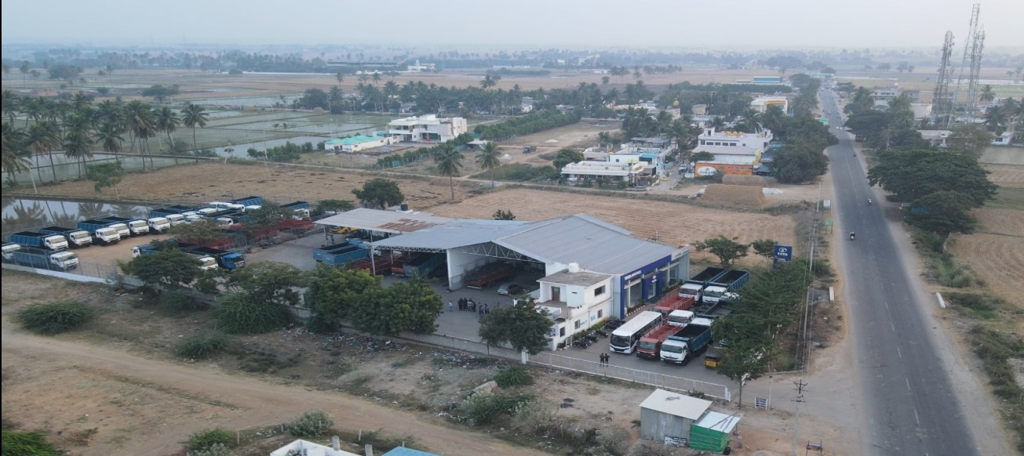On the outskirts of Gangavathi, along Sindhanur Road, we owned a piece of land.  
In 2018, when Tata Motors issued us the Letter of Intent (LOI) to become their 3S dealer, we established a new 3S dealership on that land.

This facility operates with nine advanced service bays, which include a machine shop, a wheel alignment system, and a water service facility.  
After being formally appointed as a Tata Motors dealership company, a grand inauguration function for Janatha Automobiles Private Limited was held at this facility in February 2019.

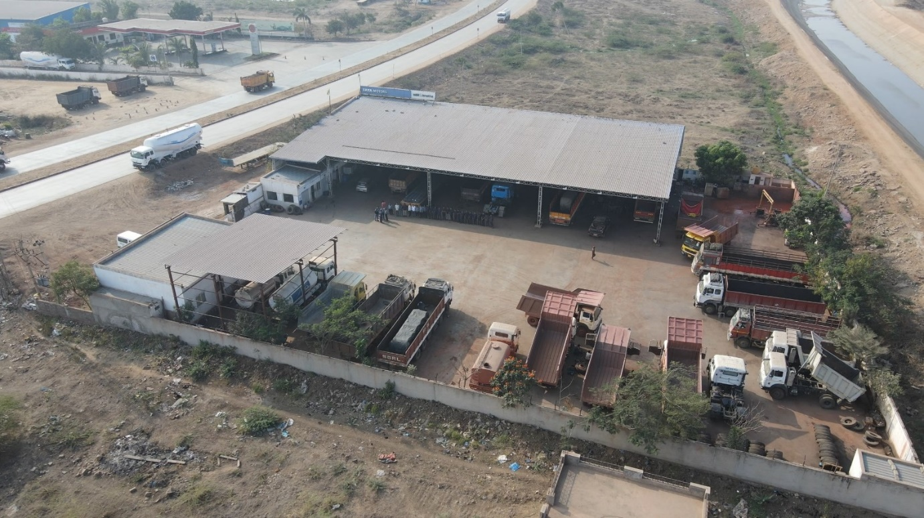**Slide 40 –** Nil, **Slide 41 -**

"This was a 7-bay workshop before becoming a TATA Motors dealership; now it is a 15-bay full-fledged workshop with a 3S facility.  
Located near the JSW Steel Plant and Sandur Mines, which is a key logistics hub, this workshop can easily provide services to nearby towns and industrial areas."

**Slide 42 –**

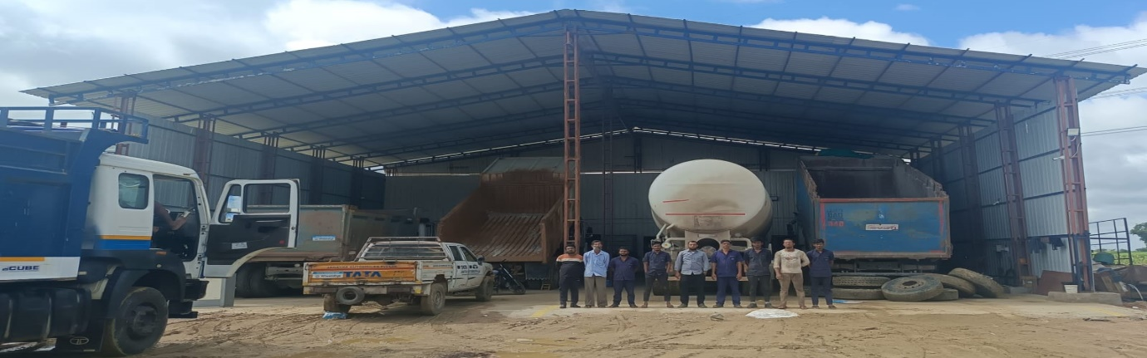In the history of Janatha Auto Works, we never had a presence in Raichur.  
However, after becoming a TATA Motors 3S dealer, we were granted permission to operate in the Raichur territory.  
Therefore, in 2019, we established a 6-bay service workshop in Raichur, which proved instrumental in promoting TATA vehicles in the Raichur market through our sales efforts.  
Through this service setup, we established a presence in both sales and service in the region and, with the support of TATA Motors and our Janatha team, secured bulk deals."

**Slide 43 –**

"All our workshops have been built on our own land. However, when we started our operations in Hospet, we were operating in a rented space. Due to its location within city limits, it was quite challenging to bring M&HCV vehicles to the workshop. To solve this problem, we had to search for a better location.

In 2019, we purchased land on NH50, Bangalore Road, and constructed a modern 25-bay workshop. This facility is designed according to TATA's specifications and is equipped with all modern amenities. It also includes a dedicated body shop division with 6 bays, providing us with complete service capabilities."

**Slide 44 –**

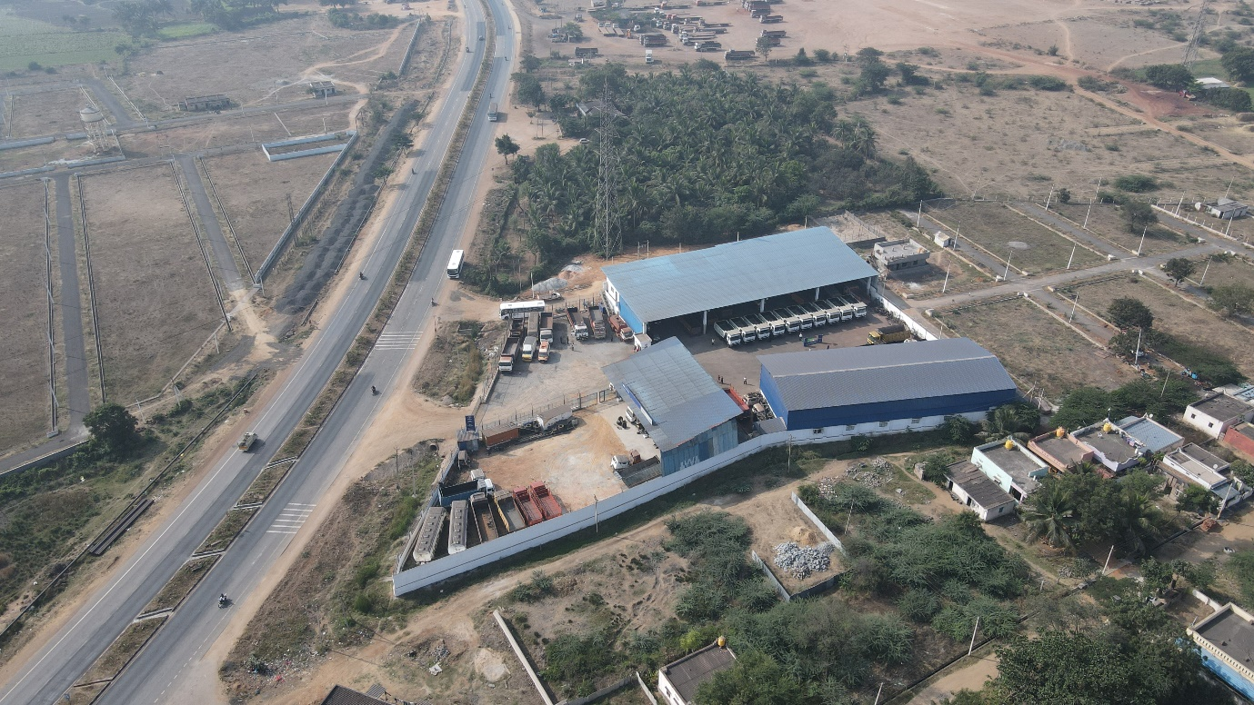Our Danapur facility

**Slide 45 –**

In our first year of operations, we achieved a remarkable sales milestone. This success was made possible due to coordinated efforts from Tata Motors' team, Our sales, service, and spare parts teams.

2019 TOTAL YEAR SALES

514 Units

This was a major accomplishment for Janatha Automobiles in its first year as a Tata Motors dealer."

**Slide 46 –**

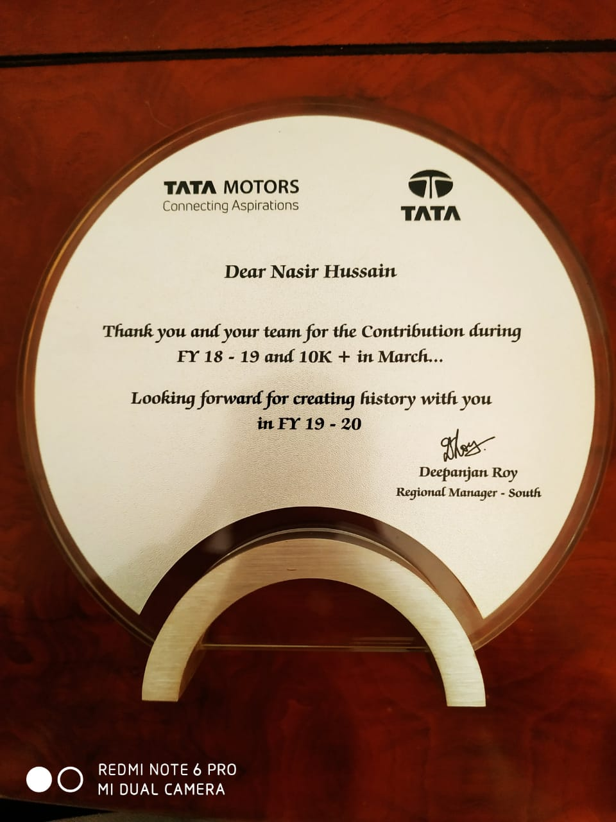"In its very first year, Janatha Automobiles Private Limited, as an authorized dealer of Tata Motors commercial vehicles, achieved remarkable success.

We set a new record by selling the highest number of 42-ton vehicles across the entire state of Karnataka.

Recognizing this outstanding accomplishment, Tata Motors honored us with an appreciation award."

**Slide 47 –**

“Our Sales Team, 2024”

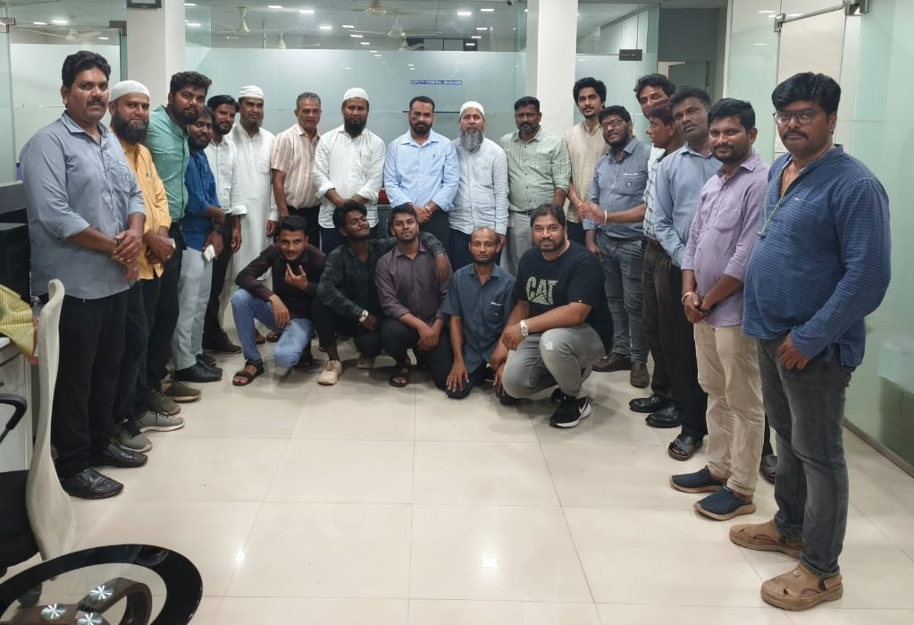



**Slide 48 –**

****After working with WABCO in Chitradurga since 2015, based on our work and reputation, we were also appointed as an Authorized Service Center for the Hospet region in 2019.

**HOSPET**

**Slide 49 –**

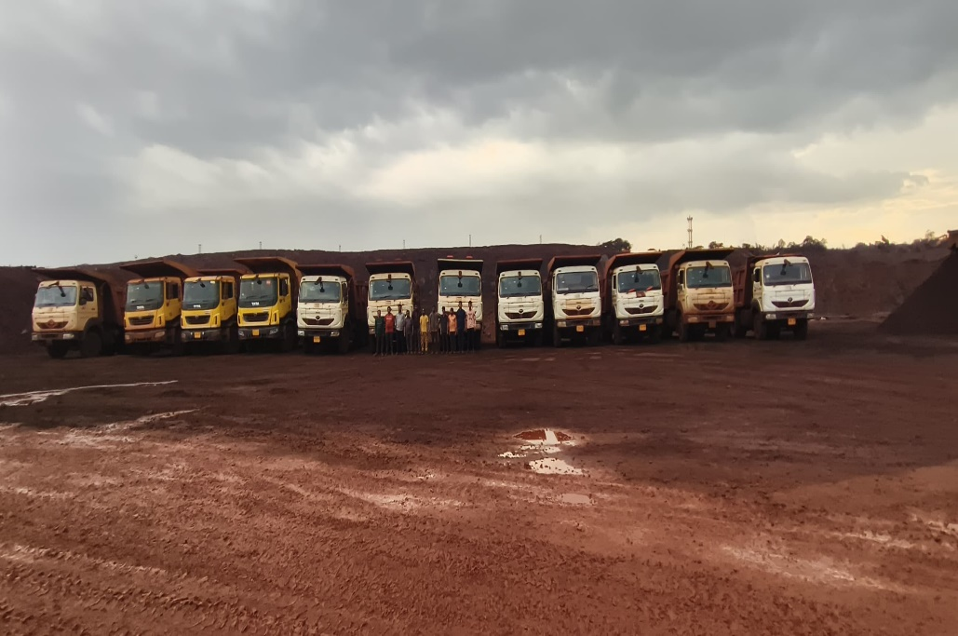"Considering our previous work with Rocktech, we were awarded a new work order in 2019 for three years, which was later renewed for another three years.

For development work at NMDC Mines, we deployed 30 TATA Signa 2825 mining tippers. This work is still ongoing.  
In 2020, we also received a work order from S M Minetech for three years at Bhadra Mines, where we deployed 20 TATA Signa 2825 mining tippers."

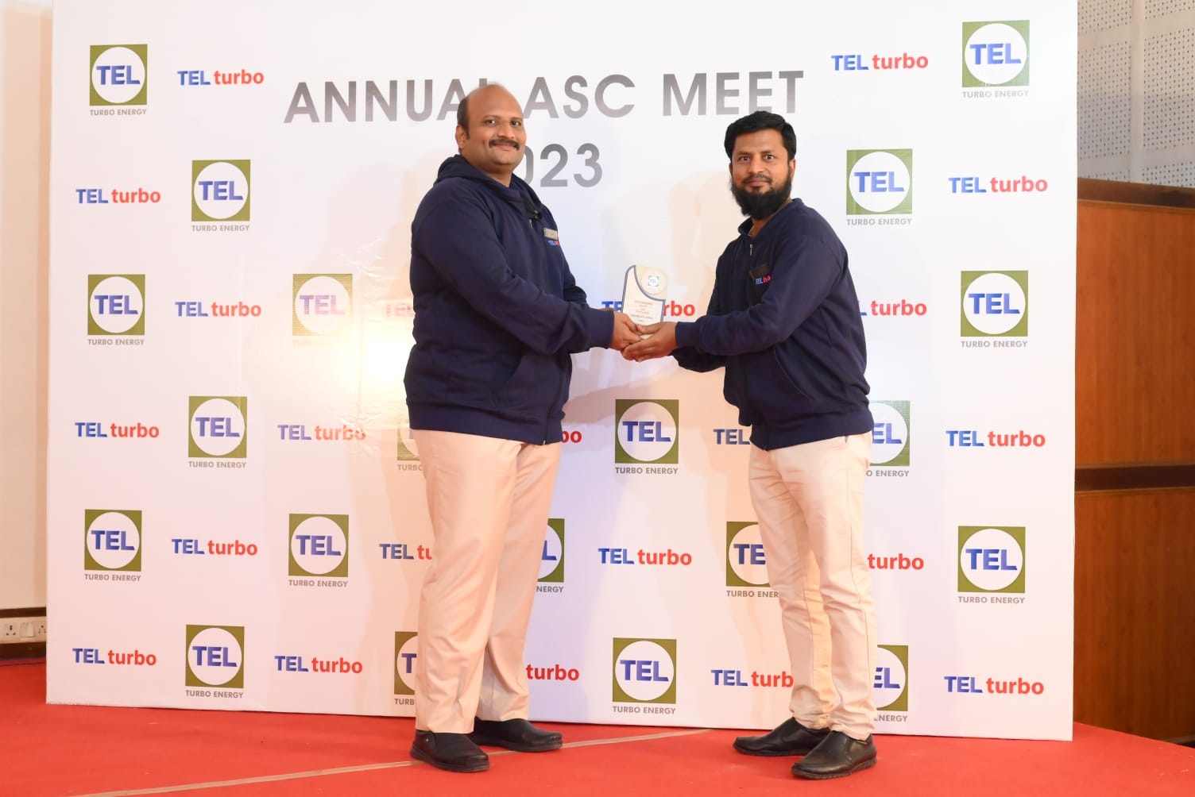**Slide 50 –**

"OEM Turbo Energy Limited awarded Janatha Auto Works the Best Performance Award for outstanding turbo sales and service in 2022-23.  
This award was presented during the Dealer Conference in December 2023."

**Slide 51 –**

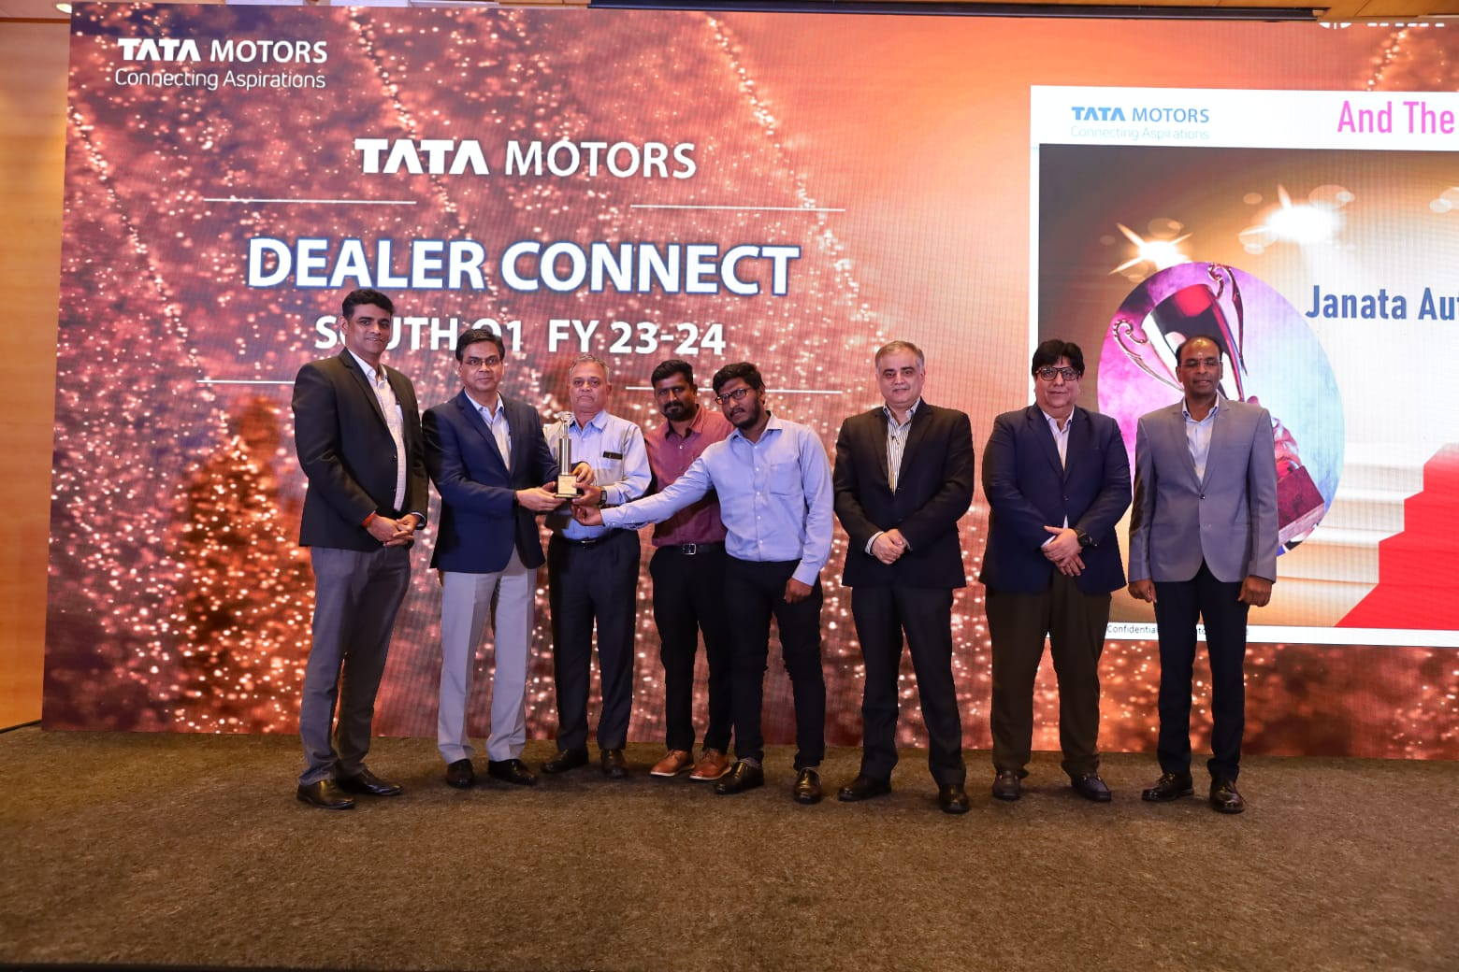"This award was presented to Janatha Automobiles Pvt. Ltd. by TATA Motors during the Quarterly Sign-Off Meeting for Best VME Realisation (Discount Sales Growth) in the South Zone."

**Slide 52 –**

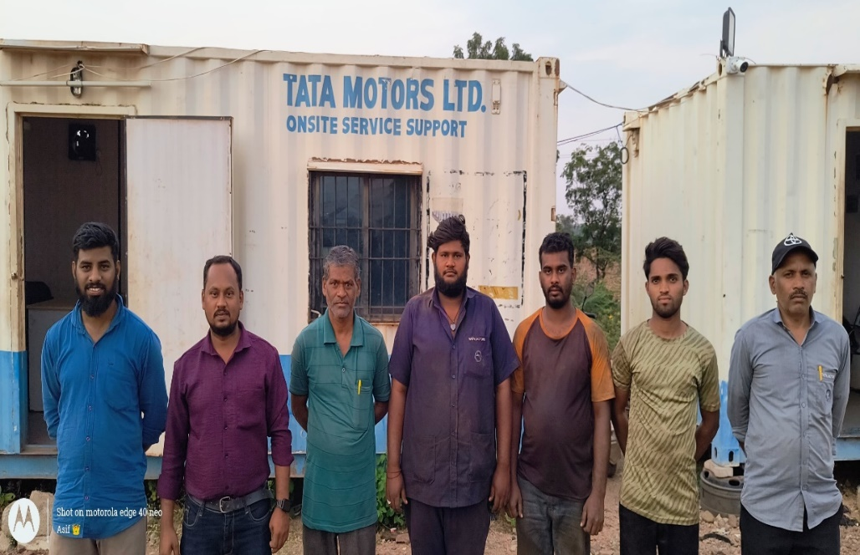"With the intention of being closer to customers, in 2022, we purchased land in Bellary and started a container workshop. Construction for a full-fledged 9-bay workshop has now begun at this site. It is located on the Anantapur-Bangalore Bypass road in Bellary."

**Slide 53 -**

"In 2023, Tata Batteries contacted us and offered a dealership (sales and service) for three districts - Raichur, Hospet, and Bellary. This has greatly helped us in resolving warranty issues for our TATA customers."

**Slide 54 –**

"In 2023, we reached out to Cummins and requested to establish a CCC (Components Care Center) to address the sales and service needs of all Cummins components. In 2024, Janatha Auto Works was authorized and appointed as the CCC for the Chitradurga, Hospet, Bellary, Davangere, and Shimoga districts. This partnership with Cummins has proven to be very helpful in resolving TATA vehicles' warranty issues."

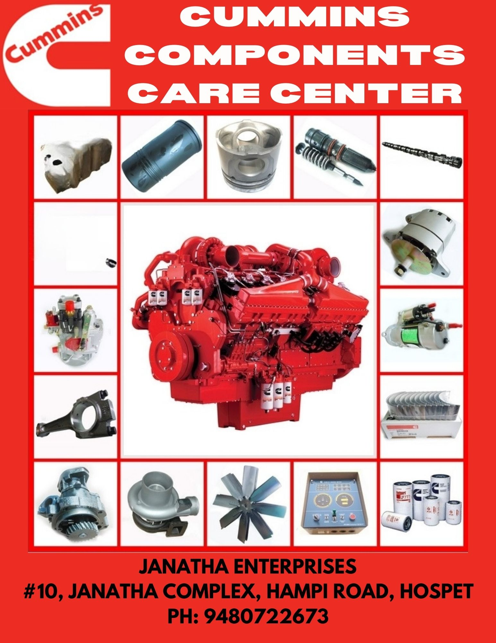

**Slide 55 –**

"Our journey with TATA Motors, which began in December 2018, has been truly remarkable. The details of our performance until November 2024 are provided in the table below. Generally, we have consistently achieved good growth, although we faced some decline during the 2019 market recession and the two challenging COVID years of 2020-21.

With the hard work of our sales and service teams, and by Allah's grace, we successfully overcame these challenges and achieved outstanding growth."

SALES PERFORMANCE JAN 2019-NOV 2024

|  |  |  |  |  |  |  |  |  |  |  |  |  |
| --- | --- | --- | --- | --- | --- | --- | --- | --- | --- | --- | --- | --- |
|  | **2019-20** | | **2020-21** | | **2021-22** | | **2022-23** | | **2023-24** | | **2024-25** | |
| **LOB** | **Retail** | **Off take** | **Retail** | **Off take** | **Retail** | **Off take** | **Retail** | **Off take** | **Retail** | **Off take** | **Retail** | **Off take** |
| **Buses** | **47** | **47** | **4** | **6** | **11** | **10** | **46** | **46** | **44** | **47** | **59** | **57** |
| **HCV Cargo** | **149** | **150** | **133** | **140** | **277** | **301** | **434** | **448** | **279** | **245** | **102** | **101** |
| **HCV Const** | **243** | **252** | **122** | **148** | **237** | **231** | **181** | **166** | **196** | **218** | **116** | **116** |
| **ICV Trucks** | **57** | **59** | **51** | **63** | **102** | **93** | **105** | **116** | **106** | **101** | **47** | **41** |
| **LCV** | **15** | **16** | **10** | **10** | **15** | **16** | **20** | **19** | **19** | **19** | **7** | **9** |
| **MCV Trucks** | **3** | **5** | **6** | **6** | **26** | **26** | **10** | **10** | **19** | **22** | **25** | **25** |
| **Grand Total** | **514** | **529** | **326** | **373** | **668** | **677** | **796** | **805** | **663** | **652** | **356** | **349** |

**Slide 56 -**

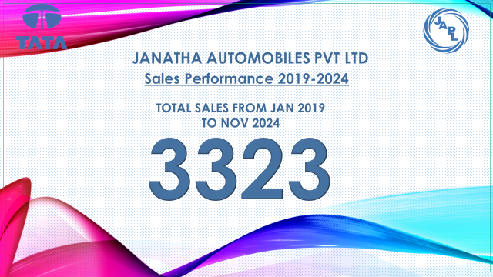"This milestone of 3,323 vehicle sales in our 6-year journey was made possible only through the collective efforts of our Sales and Service team, with the support of the Tata Motors team. We are grateful for the hard work of the entire team and congratulate each one for their dedication and determination in achieving excellence. We also thank our customers who became a part of our growth journey and showed their trust in us."

"This milestone includes M&HCV, ILCV, and buses."

**Slide 57 –**

"By the grace and mercy of Allah, and the hard work and dedication of our service team, we completed 1,11,986 job cards from December 2018 to November 2024 over the span of 6 years, achieving a revenue of 94.69 crore from labor and spares.

On achieving this revenue growth, we congratulate every member of the entire JAPL team involved in sales and service and thank Tata Motors for helping us reach this milestone."

|  |  |  |  |
| --- | --- | --- | --- |
| **Year** | **No. of JC** | **Spares Revenue in Cr** | **Labour Revenue in Cr** |
| **FY18-19 (Jan2019 - Mar 2019)** | **361** | **0.1572** | **0.0338** |
| **FY 2019-20** | **16,298** | **7.11** | **1.04** |
| **FY 2020-21** | **19,976** | **8.16** | **1.85** |
| **FY 2021-22** | **21,518** | **14.26** | **2.57** |
| **FY 2022-23** | **19,492** | **15.87** | **2.56** |
| **FY 2023-24** | **22,740** | **20.29** | **2.87** |
| **FY 2024-25** | **11,601** | **15.79** | **2.13** |
| **TOTAL** | **1,11,986** | **81.64** | **13.05** |

**Slide 58 –**

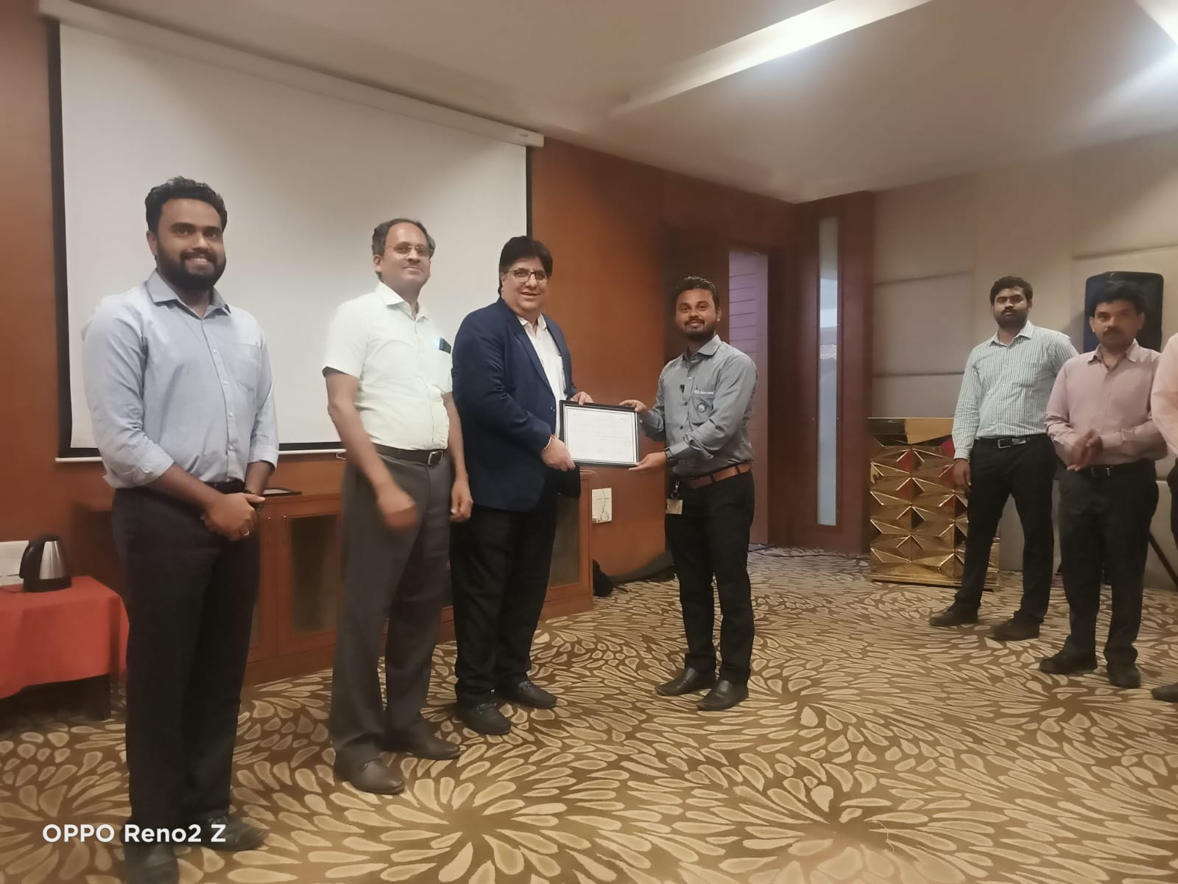"Due to our strong sales and service team, the support of Tata Motors, and the trust of our customers, Janatha Automobiles set a record by securing two Fleet Management Solutions (FMS) accounts in a single day – Mehta Logistics and Annu Transport. This milestone was the first PAN India and also the first in the North Karnataka (Hubli) region.

For this achievement, Janatha Automobiles Private Limited was awarded in May 2023 for their outstanding service performance and for promoting Fleet Management Solutions in the territory."

Janatha Automobiles also received the Best CRO award for the ASO Hubli region."

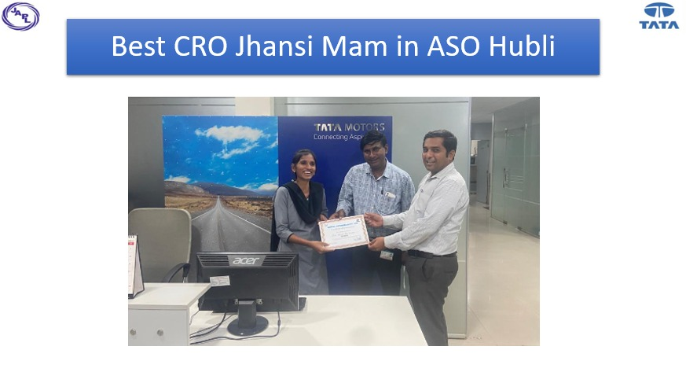

**Slide 59 – Nil,**

**Slide 60 –**

"Founder G. Dada Sab overcame many challenges in life with his strong mindset and vision. The secret to his success lay in his dedication and his focus on taking care of his customers. He stood by his customers during every difficult time and continually added value to their lives. He dedicated his entire life to his work.

His passion for work inspired many people around him. He taught values of sincerity and business ethics, and encouraged understanding people's problems and providing solutions for them. As a mentor, he guided the next generation through his vision, teaching them the true principles and ethics of business that would help them achieve success and excellence in life."

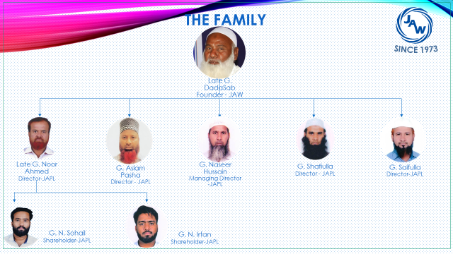

**Slide 61 –**

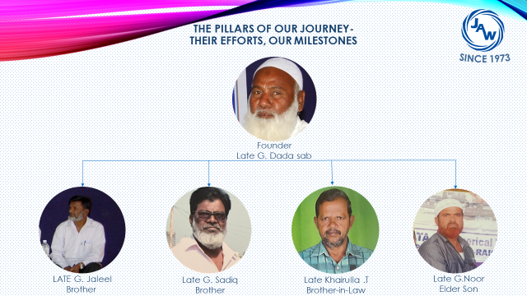**The Pillars of Our Journey – Their Efforts, Our Milestones**

"Behind every successful organization, there are remarkable individuals whose unparalleled dedication and strong will pave the way for its success. The 50-year remarkable journey of Janatha Auto Works is no different, with exceptional people at the heart of it—people who became an example of hard work, integrity, and passion. These individuals are the foundation upon which Janatha Auto Works stands strong today, and they have set the standards of success for future generations.

These individuals were not just contributors but the heart and soul of Janatha Auto Works. With their passion and dedication, they transformed challenges into opportunities and turned dreams into reality. Their courage and spirit infused life into every task, teaching us how hard work and commitment can lead to achieving every goal."

"The challenges they endured, the sacrifices they made, and the principles they taught have become an invaluable legacy for the next generation. They showed us that success is not just a wish but a passion that can be achieved through continuous hard work and integrity. They taught us that there is strength in unity, and with a shared vision, any goal can be accomplished.

Today, as we celebrate the 50th anniversary of Janatha Auto Works, we fondly remember those foundational individuals. Their dedication and wisdom gave the organization the honor and respect we see today. Their story is not just a reflection of their contributions but a lesson for all of us on how to keep their legacy alive and honor their name.

Janatha Auto Works is what it is today because of their hard work and wisdom, and we will forever be grateful for their contribution. In the future, we are committed to following the principles they taught us and building a strong foundation on the legacy they laid, so that their legacy lives on in every phase of our journey."

**Slide 62 – Hamare Kamyabi Ke Saathi –**

"In every successful company, there are certain people whose loyalty and hard work become the true reason for its progress.

At Janatha Auto Works, we are fortunate to have such individuals who have been with us for over two decades.

They are the true partners of our journey, and their contribution to the success of Janatha Auto Works is immense."

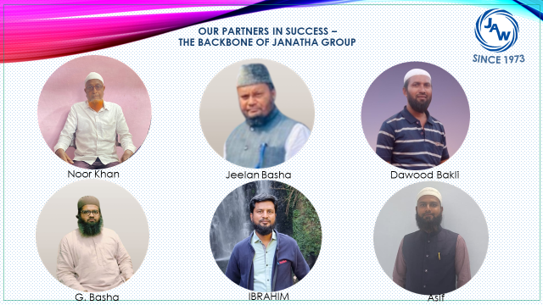

**Slide 63 –**

"Through both good and bad times, their hard work and dedication have been a source of strength for us. They have witnessed our challenging moments, shared in our joys, and provided full support in every task.

Their hard work and unwavering support have helped us make tough decisions and overcome numerous challenges with ease.

These individuals are the true exemplars of hard work, friendship, loyalty, and teamwork—qualities that define Janatha Auto Works.  
They have not only helped build our company but also fostered a culture of integrity and dedication that will inspire future generations."

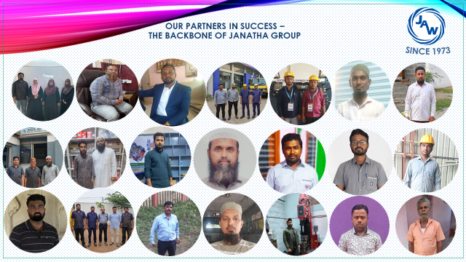

**Slide 64 -**

"As we celebrate the 50th anniversary of Janatha Auto Works, we sincerely thank all our old and loyal partners. These individuals are the true heroes of our company’s struggle, and their impact is evident in every aspect of our success.  
We are grateful for their support and hope to continue this journey with them, moving forward in even better ways."

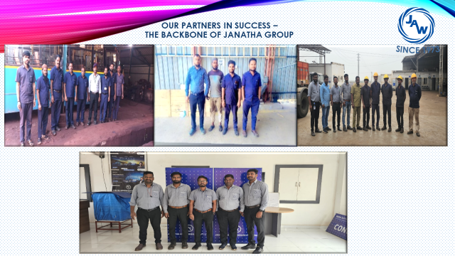"As we celebrate the 50th anniversary of Janatha Auto Works, we sincerely thank all our old and loyal partners. These individuals are the true heroes of our company’s struggle, and their impact is evident in every aspect of our success.  
We are grateful for their support and hope to continue this journey with them, moving forward in even better ways."

**Slide 65 –**

**"Thank You to Those Who Have Been a Part of Our Journey"**"We are also deeply grateful to those who were once part of our team and later sought new paths in life, exploring different opportunities. On this occasion, we extend our heartfelt thanks to them and acknowledge their contributions. Everything we have achieved today is a reflection of their hard work and dedication. We wish them all the success and prosperity in life."  
**"Our Success is Your Success, Your Success is Our Success."**

**Slide 66 –**

The Prophet Muhammad (Peace Be Upon Him) said:

**"The hand of Allah is with the group." (Sunan al-Tirmidhi, Hadith 2167)**

This hadith emphasizes the importance of unity, working together, and supporting one another.

It shows that when everyone moves forward together, success naturally follows.

**Slide 67 –**

**Thank You**

**----------------------------------------************--------------------------------------**